To: Tony Coleman, Purchasing, light metals
From: Supplier carbon reporting, light metals
Date: 28 January 2027
Subject: Brackwell Alloys: SCR-2 low-carbon premium on 2027 call-offs

Premium of EUR 342,000 on 9,000 t: 6063 billet and LM25 ingot qualify, 6082 billet and the castings do not
Under SCR-2 section 7 Velden pays EUR 38 a tonne on the 2027 call-offs of each Brackwell family whose 2026 specific direct emissions were 0.235 t CO2/t or less. On Brackwell's 2026 data package two families qualify: 6063 extrusion billet at 0.211 and LM25 foundry ingot at 0.168. Their call-offs of 7,200 t and 1,800 t give EUR 342,000. 6082 billet (0.263) and the LM25-TF castings (0.501) are over the limit, so their 3,000 t and 650 t earn nothing.
Family | 2026 production (t) | 2026 direct CO2 (t) | t CO2/t | Under limit | 2027 call-off (t) | Premium (EUR)
6063 extrusion billet | 22,897 | 4,840 | 0.211 | yes | 7,200 | 273,600
6082 extrusion billet | 8,205 | 2,160 | 0.263 | no | 3,000 | 0
LM25 foundry ingot | 12,816 | 2,160 | 0.168 | yes | 1,800 | 68,400
LM25-TF sand castings | 2,044 | 1,030 | 0.501 | no | 650 | 0
Total | 45,961 | 10,180 |  |  | 12,650 | 342,000
Production is the tonnes that passed Brackwell's final inspection in 2026, each lot at its last result. Direct CO2 is the gas each family's processes burned plus its tonnage share of the gas no process burned, at 0.18296 kg CO2/kWh. CO2 rounded to 10 t.
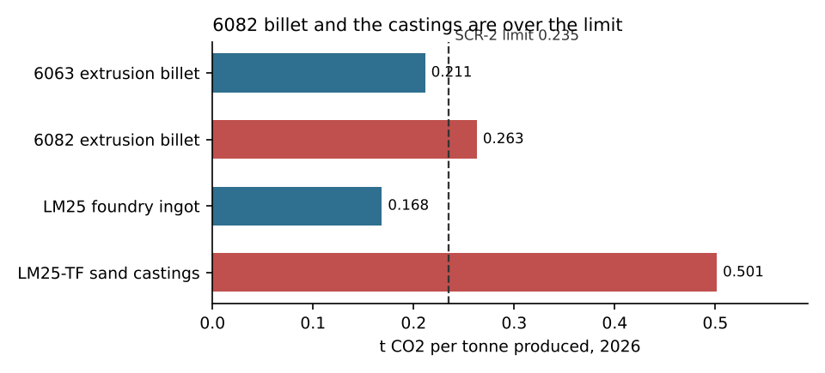

How the gas was attributed
Brackwell burns all of its gas through one site meter, so the gas each process burned has to be read from the meter. The supplier's 15-minute export (UTC; the imperial meter read in hundreds of cubic feet until the exchange on 14 April) was converted to cubic metres and then to kWh at the volume correction factor and the calorific value of the invoice covering each interval: 55,650 MWh for 2026. Each local day's gas was then regressed on what each process did that day: tonnes melted in the casthouse furnaces M1 and M2 (each heat spread from charge to melt-out, re-keyed heats dropped), tonnes charged to the foundry tower melter M3, hours the homogenizing furnace H1 and the solution oven T1 fired (door closed to door opened), and heating degree days on base 15.5 C from the works' weather station.
The fit explains 99.9 per cent of the daily variation. It gives 819 kWh a tonne melted in the casthouse, 612 kWh a tonne in the tower melter, 1,506 kWh an hour in the homogenizing furnace and 573 kWh an hour in the solution oven, with 2,564 kWh a day of pilot flames and 1,031 kWh a degree day of space heating.
The homogenizing furnace burns by the hour whatever the load weighs: a 6082 load soaks about 15 hours against about 6 for 6063, so 6082 billet carries 47 per cent of the furnace's gas on 26 per cent of its tonnes. Shared by tonnes, both billet alloys would sit at the same 0.225 and 6082 would qualify. The castings carry the tower melter and the solution oven, and melt about 1.65 t for every tonne that passes inspection. The gas no process burned (3,261 MWh) is shared by tonnes produced, as SCR-2 section 3 sets out.
Sources: Brackwell SCR-2 data package of 21 January 2027 (site gas meter export, Northgate gas invoices, furnace and oven logs, production lots, weather); Velden call-off schedule 2027, revision 0.

