Education Committee
S1 to S3 mathematics: the 2025-26 change that cost the most marks in June 2026
Report by the Performance and Improvement Lead, Education Service. June 2026.
Recommendation
The change that cost S1 to S3 pupils the most marks in the June 2026 common papers was the homework platform switch, Mathsbridge in place of Corvella (change B). The committee is asked to recommend that the 2027-28 budget reverses it.
What happened in June
4,346 pupils sat the June 2025 papers and 4,426 sat the same papers in June 2026. The mean mark fell from 32.3 to 30.3 out of 60, and the share of pupils at 36 or more fell from 42% (1,832 pupils) to 36% (1,587 pupils). Every school fell (chart).
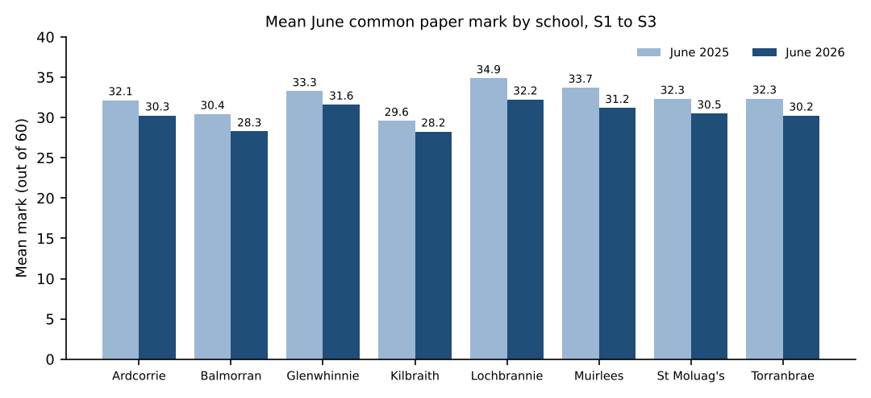
Why the platform switch
The two changes that reached every pupil on the same day, the framework and the platform switch, cannot be told apart by comparing groups of pupils, so we compared each pupil's own units. Taking the units each pupil got most wrong in their first homework on the unit (their bottom third by first-attempt accuracy), those units sat 15.1 points of a unit's marks below the same pupil's other units in June 2025, under Corvella, and 20.5 points below in June 2026, under Mathsbridge. Corvella's weekly retrieval tasks were drawn for each pupil from the skills they had got wrong; Mathsbridge sets each class the same review. The units pupils first struggled with stopped coming back to them, and stayed weak to June, across every school and year group.
Why each other change cost fewer marks
Framework (A): the four rewritten units in each year group did fall further than each pupil's other units against June 2025, but by less than each pupil's weak units fell, and they are four units of twelve; the carried-over units fell no further than the platform effect explains.
Asymmetric week (C): it reached S3 pupils only (1,491 sat), whose shortfall against S1 and S2 grew a little against June 2025 once P7 attainment and free school meals are allowed for.
Support bases (D): the heaviest loss a pupil of any change, but it reached only the 241 pupils referred to a base who sat in June.
Shared posts (E): it reached the 587 pupils in the split classes, and only from January.
Base use and teaching continuity by school
School | Maths lessons missed in a base | Classes with more than one teacher
Ardcorrie Academy | 24 | 6
Balmorran High School | 20 | 5
Glenwhinnie Academy | 22 | 9
Kilbraith Academy | 19 | 7
Lochbrannie High School | 15 | 3
Muirlees High School | 27 | 12
St Moluag's High School | 24 | 3
Torranbrae High School | 18 | 5
Lessons are S1 to S3 maths lessons a pupil was signed in to a base for any part of, from 3 November to the papers, booked to the pupil's own school and to the class they were in on the day. Classes count the people who taught each S1 to S3 maths class on the timetable over the session.

