Vehicle interaction programme for 2027
To: Site safety steering committee, meeting of 19 November 2026. From: Health and Safety Superintendent. Under HSE-TOR-026 and improvement notice IN-2026-0417.

Recommendation
Fund programme C, the collision avoidance alerting review on the haul truck units. The rise in vehicle interaction incidents, from 24 in July to October 2025 to 89 in July to October 2026, came with the 5.0.2 firmware on the haul truck units: since it went on, operators slow for a critical alert about a third of the time, where on the earlier firmware they slowed for nearly nine in ten, and the critical alerts nobody slows for now run at more than five times last year's level.

What drove the rise
- The firmware went on truck by truck between 2 and 23 June 2026, so for three weeks the same crews drove trucks on both. Reading each critical alert in those weeks against the truck's speed in the event window the dispatch system opened on it, operators slowed by 6 km/h or more within six seconds for about 85 per cent of critical alerts from units still on 4.3 and for about 30 per cent from units already on 5.0.2.
- The change is in the alerts, not in who was driving: from July, with every unit on 5.0.2, operators slow for about one critical alert in three, against nearly nine in ten in every month to May.
- Alert volumes and acknowledgements did not move, which is why the vendor's report shows nothing: operators still press acknowledge, they no longer brake.
- Not B: the North ramp junction has the most incidents, and more trucks ran the North waste route from June, but per 1,000 truck shifts in July to October the South pit ore route, which never passes the junction, went from 2.2 to 9.2 incidents, against 8.4 to 21.3 on the North waste route through it.
- Not A: the operators' attention did not fall across the board; the same crews slowed on 4.3 units in June.
- Not D or E: the fall in slowing came with the firmware on day shifts as on nights, and the crusher pad's share of incidents fell.

Monthly incidents
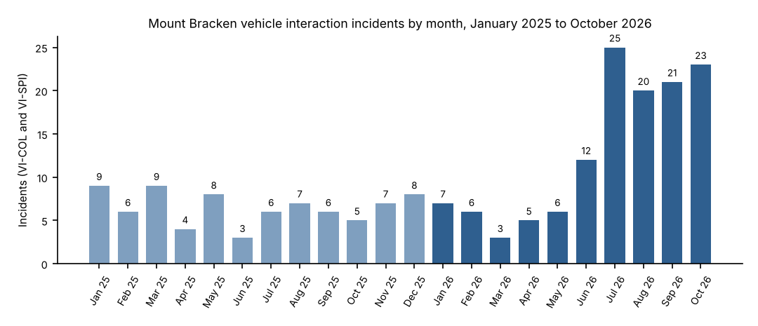
Counts are register entries classified VI-COL or VI-SPI, by month of occurrence, Western Australian time (HSE-TOR-026, 2.1).

