FENMORE SAVINGS BANK
The relief-era SBA loans need a $10 million allowance at 30 September 2026
From: Erin Spence, Controller. For the Board's October meeting (CP-SBA-07, 6.1).
We will book an allowance of $10 million on the unguaranteed portions of the 7(a) loans approved in fiscal years 2019 to 2021.
It is $2.0 million on the fiscal 2019 approvals, $3.0 million on fiscal 2020 and $5.0 million on fiscal 2021, against unguaranteed principal of $197.5 million on 5,110 loans still on the books, 67 of them in default.
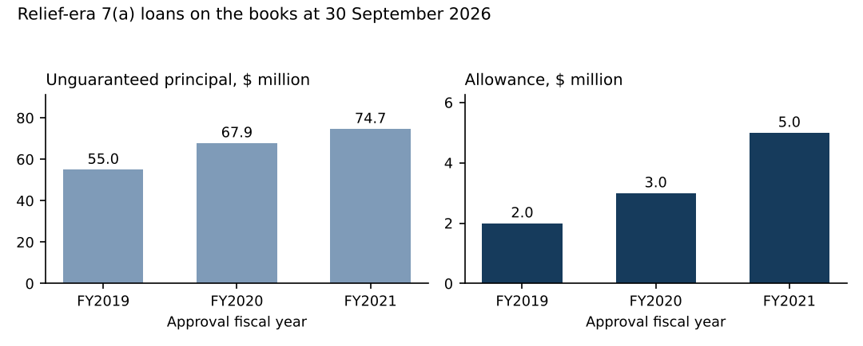
Source: servicing history and guarantee register at 30 September 2026; allowance under CP-SBA-07. Unguaranteed principal includes the 67 loans in default not yet charged off.
The figure prices each loan with the loans its guarantors stand behind. 2,036 of these loans belong to 988 operators who guarantee other businesses financed by the bank, and the loan authorization cross-defaults every such loan: when one of an operator's businesses fails, we accelerate all of them. Those operators added 1,403 units in fiscal 2026 alone, outside this pool. Businesses fail most in their second to fourth years, so the pool's risk now sits largely in units that are only months old, and it reaches these loans through the cross-default.
Each loan is carried at the probability that the first failure among its group's performing loans, each at its own age, comes before the loan pays off or matures, on failure rates measured on businesses standing alone since October 2009, times the share of defaults the bank has charged off (91.8 per cent), on the unguaranteed principal scheduled for the month of default at 30 September 2026 rates. Loans already in default are carried at that share. Recoveries are not counted (CP-SBA-07, 2.1).
Workbook: sba_allowance_fy2026.xlsx, with the Section 1112 payments on these loans by quarter and their net charge-offs by fiscal year.

