Eight-problem sets keep the spring reteach groups inside the funded places
To: Tara Richardson, Chief Academic Officer
From: Linda Ramos, Mathematics Coordinator, Grades 6 to 12
Date: 27 October 2026
Subject: Set length for the spring in-class skill builders (Units 4 to 7)
Recommendation. Set the spring skill builders at 8 problems before the five-problem check. We expect about 3,500 failed checks across Units 4 to 7, inside the 4,100 reteach places the amendment funds. Six problems would produce about 4,500, more than the places; ten would bring the figure down to about 2,750 and spend two more problems of every period for a cut we do not need.
Why last year's homework cannot simply be carried over
The spring check comes at the end of one class period, straight after the set. Nothing in the homework record looks like that. At home a student stops the moment they have three right in a row, so the students still answering a skill builder's ninth or tenth problem are the ones who were struggling with it; the accuracy of those late problems describes them, not the class. And the students who needed more than one evening for a skill builder came back to it well below where they had finished the evening before. Read as one learning curve, that drop looks like slow learning. It is not what a student will do inside one period, where there is no night in between.
So the forecast separates the two. Using every seventh grader's first attempts in 2025-26 and this fall, it estimates each student's level and, for each skill builder, how much a student gains with each problem inside a sitting, counting the problems from earlier evenings apart. It then works out, for each of the 2,402 seventh graders on roll on 23 October, the chance of fewer than three of the five check problems right after a set of 6, 8 or 10 problems in one sitting, allowing for how much we know about each student from this fall, and adds them up.
The two shortcuts would have sent us the wrong way. Replaying last year's homework, where most students eventually finished, makes even six problems look comfortably inside the places. A learning curve fitted across evenings reads the overnight loss as slow learning and puts every length over the places.
Expected failed checks (nearest 250)
Set length | Expected failed checks, Units 4 to 7 | Within the 4,100 places
6 problems | 4,500 | No
8 problems (recommended) | 3,500 | Yes
10 problems | 2,750 | Yes

At 8 problems | Expected failed checks
Unit 4: Percent Problems | 750
Unit 5: Equations and Inequalities | 1,250
Unit 6: Angles, Area and Volume | 750
Unit 7: Probability and Sampling | 750
Source: Pellmore problem logs, August 2025 to 23 October 2026; SIS roll of 23 October 2026. Figures rounded to the nearest 250; a place is one student in one unit's reteach group, so the four units add.
At 8 problems Unit 5, Equations and Inequalities, carries the most, about 1,250: students gain little on it with each extra problem, so a longer set helps it least. Unit 4, Percent Problems, starts hardest but students pick it up quickly within a sitting, and by 8 problems it is down to about 750.
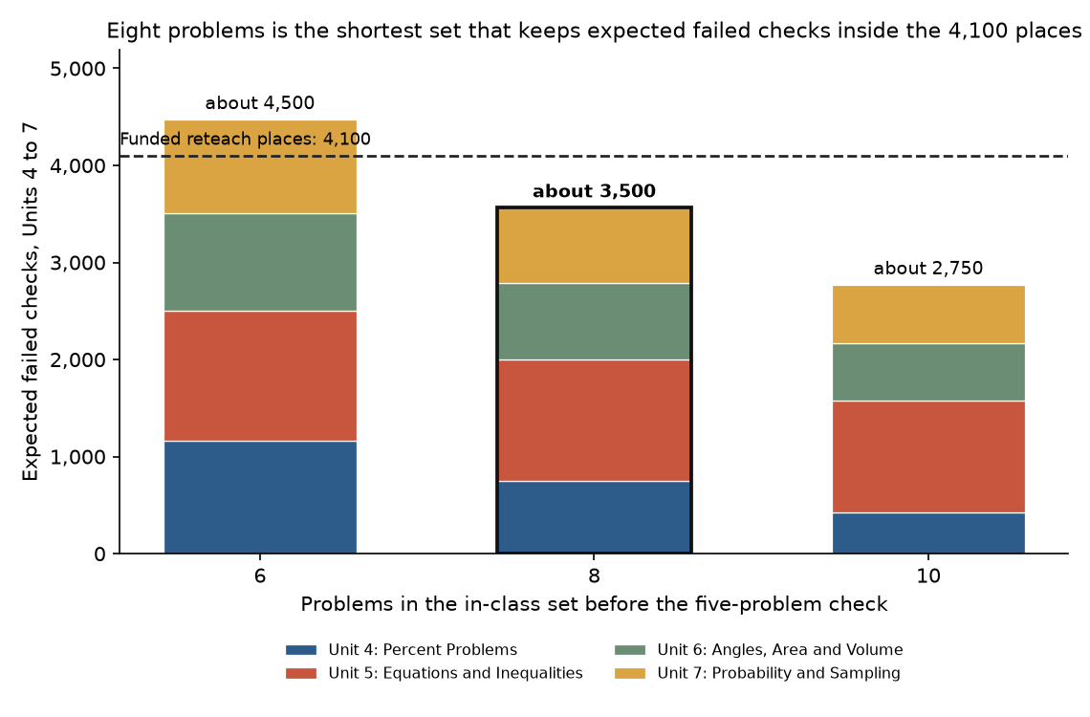
Context in the workbook
The workbook also lists each school's 2025-26 skill-builder problems on each of Units 4 to 7, counted at the school each student attended on the day the problem was started (143,550 in all). It does not change the length; it shows principals how much homework practice the in-class sets replace.
What could move it
The forecast assumes students work through a set in class the way they worked through one evening at home. Unit 4's checks, from 5 January, are the first test of that.

