Budget 2027: the duty envelope should go to spirits
For decision. 26 October 2026. From Rhys Armstrong, the panel's expert adviser, to the Economic Affairs Scrutiny Panel (Chair, Deputy Aimee Miah) for its meeting on 2 December 2026 and its amendment to the 2027 Budget, debated on 15 December.
Recommendation: the panel's amendment gives the GBP 1.5 million to spirits duty, cutting its 2027 rate of GBP 10.82 a litre by about a fifth from 1 January 2027. The cut removes about GBP 0.9 million of excess burden in 2027. The next best is cider duty, which would remove about GBP 0.4 million.
Every litre a duty cut adds to what people buy carries the whole of the duty and GST still charged on it, and that is where most of the gain is. Spirits carry the largest wedge of the alcohol duties, 57 per cent of the shelf price, and their buyers respond within months. Road fuel carries a larger wedge still, but drivers change what they buy over years rather than months, so in 2027 a fuel cut would remove less than a fifth of what the spirits cut removes. Cider buyers respond most to price, but cider's wedge is small, so most of what a cider cut gives back is the duty itself.
The envelope given to each duty in turn:
Duty | 2027 rate (GBP a litre) | Cut (GBP a litre) | Excess burden removed in 2027 (GBP thousand)
Spirits | 10.82 | 2.26 | 882
Cider | 0.66 | 0.33 | 408
Wine | 2.37 | 0.43 | 209
Beer | 0.82 | 0.23 | 200
Road fuel | 0.8240 | 0.0260 | 150
Each cut is the one that gives up GBP 1.5 million of duty and GST in 2027 once buyers have responded. Sources: Eskerholm Statistics Office, duty-paid clearances and shelf prices, 2008 to 2026; Treasury duty rates.
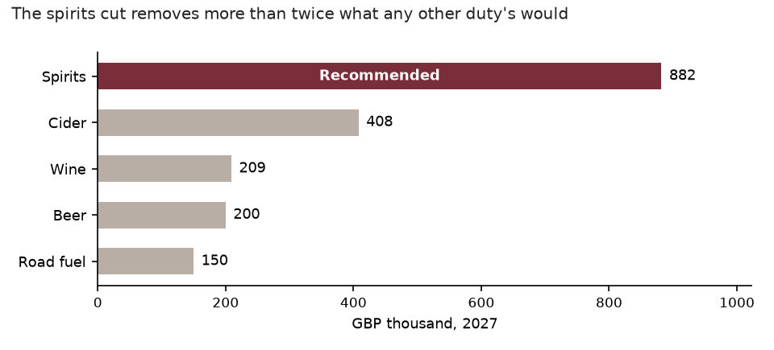
Excess burden removed in 2027 by each duty's cut; the recommended duty in red.
How it was appraised
As the appraisal manual sets out, the starting point is the latest four quarters of duty-paid clearances, each standing for the same quarter of 2027, at the latest shelf prices with the 2027 rates already set (3 per cent above 2026). A cut passes in full to the shelf price with GST on top.
How far buyers respond, and how fast, comes from the quarterly clearances and prices since 2008. For each duty we fitted log clearances on the quarter, log shelf price and the previous quarter's log clearances, which gives the response in the first quarter and the share of the gap closed each quarter after. In 2027 the response builds through the year: by its fourth quarter spirits have made 99 per cent of their long-run response and road fuel 20 per cent.
Each duty's cut is set so that the duty and GST given up in 2027, after buyers respond, is GBP 1.5 million. The excess burden it removes is the value of the extra litres to the people who buy them less what they cost to supply, quarter by quarter along the demand curve fitted for that duty: the duty and GST still charged on each extra litre, plus half the cut.
The cut is permanent and goes on removing excess burden after 2027; the manual appraises the Budget year only (section 4). Health, road safety and environmental effects are reported by the departments concerned (section 9).

