To: Executive team
From: Natalie Taylor, Subscriber Retention, Audience Revenue
Date: 25 January 2027
Subject: January retention offer: what it will keep

The January offer should keep 20 per cent of the list to 31 March
Of the 48,000 subscriptions on the 26 January list, 20 in 100 will still be subscribed on 31 March 2027 because they were sent the offer, subscriptions that would otherwise have gone. That is the rate last January's test measured on the subscribers whose next bill fell within 14 days of the send, and every bill on this year's list falls on 1 February 2027, 6 days after it.
Last January's headline figure is lower. Across the whole test list the offer kept about 10 in 100, but that average mixes the subscribers whose bill came up within two weeks of the send, where it kept about 20 in 100, with those billed later in February, where it kept almost none: an offer that arrives weeks before the bill has been forgotten by the time the subscriber decides whether to pay it. Last year each subscription billed on its own day of the month; since November every monthly plan bills on the 1st, so this year the whole list hears from us in the week before its bill.
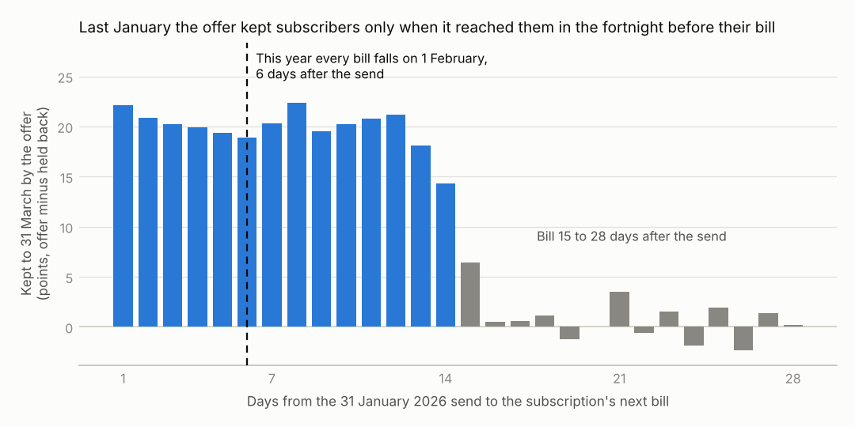
Source: retention test RET-2026-01 (160,000 subscriptions, a random half sent the offer); subscription events to 31 March 2026; legacy billing, January 2026 bills.
What last January's offer cost
On February 2026 bills last January's offer gave GBP 31,100, GBP 22,200 and GBP 12,600 on the Digital, Digital Plus and Family plans, and on March bills GBP 28,200, GBP 20,200 and GBP 11,800; 6,224, 3,174 and 1,402 subscriptions took it.
What the list brings in
In January this list was billed GBP 259,100 for Digital, GBP 200,300 for Digital Plus and GBP 136,600 for Family, after credits; the workbook has October to January by plan.
Notes
1. Subscribed means the paid period covers 31 March: a subscription's access ends on its last paid day, and one that restarted by then counts.
2. The save desk's own half price uses the same billing code as the offer and is not counted as the offer.

