IBCP | Examinations Committee | Meeting of 10 December 2026 | Paper EC 26/14
November 2026 Paper 2: 401 of 714 candidates pass, with Questions 6 and 8 moved three marks
For decision. Prepared by Stephanie Nguyen, Assessment Analyst, Examinations Office, 1 December 2026, from the marks of record exported on 30 November.
1. Recommendation
That the Committee approve the moves in Table 1 for the optional questions under regulation 14, and the Paper 2 results in nov2026_paper2_results.csv: 401 of the 714 candidates who sat the paper pass.
2. Moves under regulation 14
Candidates answer five of the eight questions, and they did not choose at random. The stronger candidates took Question 6 (fire safety performance solutions) and the weaker took Question 8 (development consent conditions), so a question's mean mark says as much about who chose it as about how hard it was. Regulation 14.1 compares each question with the average question on the same candidates, whichever questions each chose, so I read each question's difficulty from the same candidates' marks across the questions they chose: a fit of a candidate effect and a question effect over all 714 scripts, centred on the average question, each question counted once.
The candidates who answered Question 6 averaged 13.5 on their other questions and 10.1 on Question 6; those who answered Question 8 averaged 8.9 on their other questions and 12.1 on Question 8. Set against the paper's mean marks alone, Question 6 would move by +1 and Question 8 by -1, and 422 candidates would pass, 21 more than under the moves recommended here.
Table 1. Moves for the optional questions
Question | Topic | Answered by | Move (marks)
Q1 | Building classification and the NCC compliance pathways | 474 | -1
Q2 | Structural adequacy and reliance on engineers' certificates | 448 | +1
Q3 | Energy efficiency: Section J and dwelling energy ratings | 459 | 0
Q4 | Waterproofing, wet areas and external moisture | 430 | +1
Q5 | Access for people with a disability under the Premises Standards | 464 | 0
Q6 | Fire safety performance solutions and fire engineering reports | 321 | +3
Q7 | Mandatory inspections, notices and orders | 475 | -1
Q8 | Development consent conditions and the construction certificate | 481 | -3

Source: e-marking export, marks of record at 30 November 2026. The 18 candidates who answered four questions are in the fit and in the results.
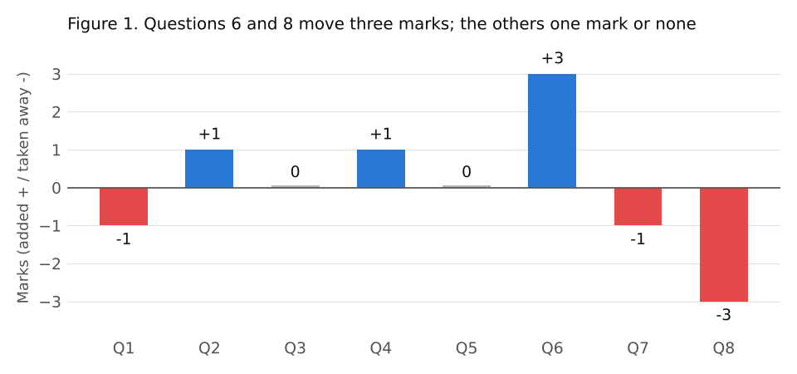
The moves were applied to every answer with regulation 14.2's limits: 20 moved marks were held at 20 and none at zero, and neither limit changes any result.
3. Results
Of the 714 candidates who sat, 401 pass and 313 fail. Scripts on 48 or 49 after the moves go to a senior examiner under regulation 15 before results are issued.
4. Withdrawals, absences and May sitters by centre
Withdrawals are dated by the time each request reached the portal (regulation 17.1), not by the day it was actioned. May sitters are the November sitters who sat Paper 2 in May, matched on membership number or on name and date of birth, as candidate numbers are issued afresh at each sitting.
Table 2. November 2026 Paper 2 by centre
Centre | Withdrawals | Absentees | Sat Paper 2 in May
Sydney | 11 | 4 | 33
Western Sydney | 4 | 3 | 16
Melbourne | 23 | 8 | 34
Brisbane | 8 | 9 | 25
Perth | 7 | 3 | 20
Adelaide | 8 | 4 | 22
All centres | 61 | 31 | 150

Source: candidate portal entries and request log at 30 November 2026; the legacy register and the marks of the May sitting. Western Sydney is the Parramatta centre, renamed on 1 August 2026.
5. May 2026 reviews
Of the May results, 11 changed on review, each from fail to pass. The review fees to refund come to AUD 2,625: the fees for those 11 reviews and for the 4 requests received after the closing date, which were declined (regulation 19.4). Fees billed to member firm accounts are refunded at the firm's agreed rate.

