To: Board of Directors
From: Paola Ayala, Libranza Portfolio
Date: 26 January 2027
Subject: Libranza Empresarial launch: first-year defaults

About 250 of the 2,400 launch loans will go into default within the first year
About 250 of the 2,400 Libranza Empresarial loans we disburse on 1 February will have gone into default by 31 January 2028, roughly one in ten. Our public servants' loans run at 1.6 per cent in their first year; the launch book will not.
A libranza is paid at source, so it falls behind almost only when the borrower stops being paid by the payroll while the loan is open. In our public book that happens to about 3 per cent of borrowers a year, and when it does, 53 per cent of those loans go into default three to five months later. Staff with a year's service at the 38 agreement employers leave at about 3 per cent a month on their own payroll registers since 2025, several times the public rate, so the same mechanism produces several times the defaults.
A model fitted to the public book's borrower attributes does not see this: public servants rarely leave, and the temporary staff who do hold loans that end before their contracts, so the book's low default looks like borrower quality. Scored on the launch file it gives about 50.
By sector the expected share in default is about 20 per cent in contact centres, 10 in retail chains, 10 in security services, 10 in logistics and courier, 10 in food processing and 5 in private clinics.
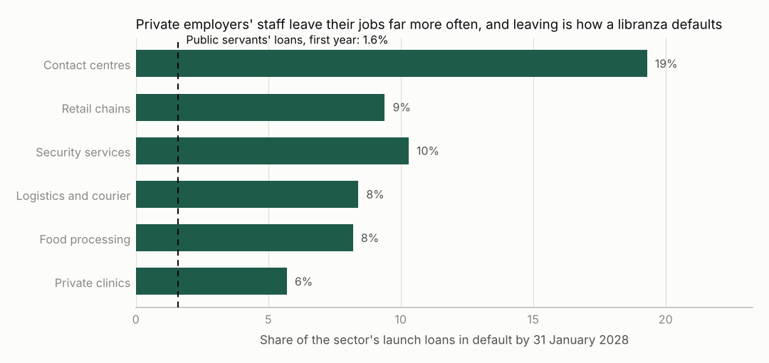
Sources: payroll loan book and Tesoreria returns 2017 to 2026; default register; the 38 employers' payroll registers 2025 to 2026; launch disbursement file of 22 January 2027.
Default is an instalment 90 or more days past due at a month-end (product rules 5.1), the definition of our annual return; the counts are expected values over the 2,400 loans. Leaving rates are each employer's own, from the staff with a year's service on its registers, since every launch borrower has saved with us for twelve months.
For the provision
The savings the employers deducted for 2026, what had not reached us by year end, and what we recovered on the public loans that went into default in 2023 and 2024 are in the workbook.

