Provincial Statistics Bureau | Prices Division | Fuel Price Monitor
To | Theodore Ellis, Fuel Price Commissioner
From | Kendra Andrews, Director, Prices Division
Date | 27 November 2026
Reference | PD-FPM-2026-41
Subject | The brand for the pass-through inquiry before the 1 January 2027 levy rise

Tallis Petroleum for the 2027 pass-through inquiry
We recommend that your inquiry before the 1 January 2027 levy rise examine Tallis Petroleum. At the 1 January 2026 rise, 30 per cent of Tallis's examined stations passed on more than the rise under standard PM-04, with the false discovery rate across all 369 stations examined held at 5 per cent. No station of the other six brands was found, so Tallis is the only brand at or above the one-in-ten share that clause 4.1 sets for an inquiry.
The stations found are Tallis's company-run sites and commission agents in Hollinsby, Greyford, Duncarrow and Marrowby, whose pump prices Tallis set itself at the change. From 1 January 2026 their margins over the rack price and the levy sat about 3 cents a litre above where they had been, and they have stayed there. Tallis's dealers in the same towns, and the other brands' stations around them, moved with their towns.
Harbourline's stations show the largest margin rises across the change, and a test of each station's change against its own day-to-day variation would find most of them. That test does not hold up. Margins in every town cycle over five to nine weeks, stations undercutting one another for a month or more and then restoring together, and Brackwater and Port Ostley, where most Harbourline stations trade, restored their prices around the turn of the year. Run at dates when the levy did not move, the same test finds a large part of every brand's stations, so it cannot hold the false discovery rate the standard sets. We judged each station's change against the 28-day changes its own margin made at every date in the log when the levy did not move; on that footing Harbourline's rises are ordinary for their towns.
Stations found at the 1 January 2026 rise
Brand | Stations examined | Share found
Garrow Fuels | 45 | 0 per cent
Harbourline Fuels | 52 | 0 per cent
Oxbury Fuels | 45 | 0 per cent
Pellow Gas | 46 | 0 per cent
Strathlowe Energy | 46 | 0 per cent
Tallis Petroleum | 92 | 30 per cent
Wexcombe Petroleum | 43 | 0 per cent
Examined: carrying the brand on the register on 1 January 2026, with a daily price on at least 20 of the 28 days on each side of the change (PM-04 3.2). Share found to the nearest ten per cent, Benjamini-Hochberg at 5 per cent across every station examined (PM-04 3.3).
The information request under clause 4.2 goes to the stations whose pump prices the brand sets: 27 for Tallis on 1 December 2026, read from the November submissions, where a brand's pricing desk sends its stations' prices through its own system at the same minutes of the day for all of them. The register's site ownership column does not give this: dealer-owned commission agents are priced by the brand and company-owned dealer-run sites are not. The accompanying workbook gives every brand's count and the litres of regular its stations sold in the first quarter, which the chart overleaf shows.
Kendra Andrews
Director, Prices Division

The litres behind each case
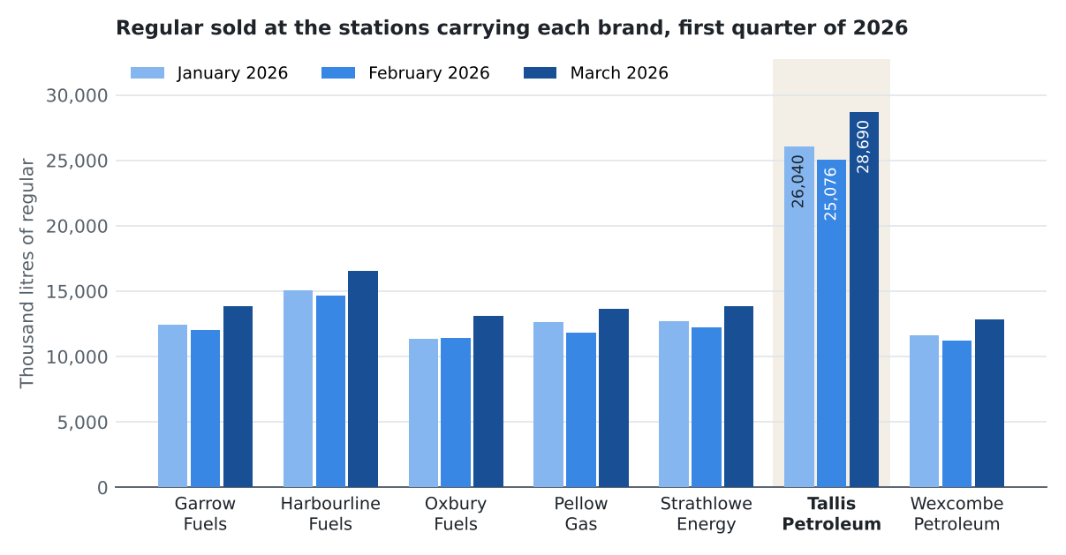
Figure 1. Thousand litres of regular sold at the stations carrying each brand in January, February and March 2026; Tallis Petroleum's bars labelled. Monthly fuel sales survey: the latest revision of each return, counted for the month it reports, at the station carrying the brand that month. 8 survey references freed when dealers closed between March and July 2026 were given to stations added to the frame from August; their January to March returns are the closed stations', found on the register by the site address each return carries.

