City of Quellbrook, Public Works, Roads Division
Report to Council
To: Mayor and Members of Council
From: Doris Wilkerson, manager, winter operations
Date: 28 September 2026
Subject: 2,200 t of seasonal rock salt for 2026-27, for approval before 1 October

Recommendation
That Council approve a seasonal commitment of 2,200 t of rock salt with Northgrit above the rolled-over 39,100 t contract, for November 2026 to March 2027.
Analysis
The commitment covers the collectors the route audit moved to Priority 1 on 30 August for Quellbrook Regional Transit's frequent network, 424.0 lane-km, sized as RO-PR-07 4.2 sets it out: the extra salt those streets will need over what they took at Priority 2, in a winter of 61.7 WSI points.
At Priority 2 our trucks salted these streets at their intersections and little else, about 700 t in a winter of that severity, under 2 t a lane-km. The collectors we moved to Priority 1 between 2022 and 2025 were mostly hill, school and hospital streets that Priority 2 already salted along much of their length, and their spreader records show the gain from the move falling the more Priority 2 salt a street already took. Read at these streets' own Priority 2 salt, the move adds about 5 t a lane-km.
The rolled-over 39,100 t carries the existing programme, whose Priority 1 arterial circuits are charted below for the last three winters. The working, each yard's dome stock and room for 1 November, and those arterial figures are in salt_commitment_2026-27.xlsx.
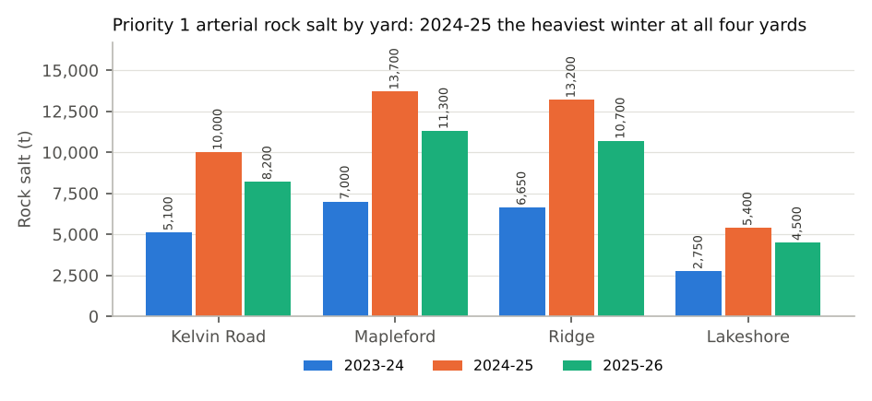
Tonnes to the nearest 50. Contract circuits are included; each yard's figure is for the arterial circuits it ran that winter. WSI is the Roads Operations Centre's Winter Severity Index (plan section 4).

