Five counties qualify for 2027 intake events
To: Jacqueline Aguilar, Director, Air Quality Division
From: Bridget Palmer, Chief, Mobile Sources Section
Date: 26 October 2026
Re: Intake counties for the 2027 Vehicle Retirement Program CMAQ request
Five of the twelve member counties qualify for intake events in 2027: Elkhollow (12 tons), Halvering (14 tons), Linnmere (13 tons), Marlbank (11 tons) and Wexmoor (15 tons). Their eligible gasoline cars and light trucks of model years 2005 to 2014 will emit 10 short tons of NOx or more in 2027 under guidelines 3.1 to 3.4. The nearest county below the line is Dunmarsh at 9 tons.
Each vehicle's 2027 miles come from its own odometer at its first inspection of the 2024 to 2025 cycle, as the guidelines require, but not as the reading divided by the vehicle's age: that is the average of every year the car has been on the road, and older cars are driven less each year. I set each reading against the cumulative miles the area's inspected vehicles had covered by the same age and took that curve's rise over 2027, so a car keeps its own level (Elkhollow's and Marlbank's drivers cover far more ground than Wexmoor's) and travels the miles its age now carries. Dividing the reading by the age instead overstates the eligible fleet's 2027 NOx by 43 per cent and would put nine counties over the line.
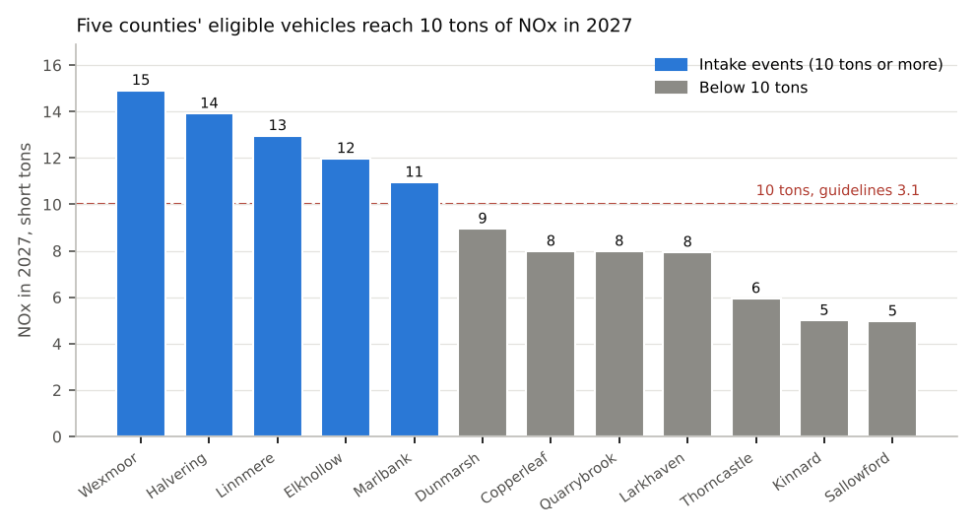
County | Eligible vehicles | With a reading | 2027 NOx, tons | Intake events
Wexmoor | 11,068 | 10,479 | 15 | Yes
Halvering | 8,688 | 8,230 | 14 | Yes
Linnmere | 7,060 | 6,667 | 13 | Yes
Elkhollow | 5,182 | 4,911 | 12 | Yes
Marlbank | 5,255 | 4,973 | 11 | Yes
Dunmarsh | 6,149 | 5,812 | 9 | No
Copperleaf | 3,135 | 2,982 | 8 | No
Quarrybrook | 4,221 | 4,016 | 8 | No
Larkhaven | 5,047 | 4,791 | 8 | No
Thorncastle | 4,119 | 3,889 | 6 | No
Kinnard | 2,814 | 2,681 | 5 | No
Sallowford | 2,567 | 2,434 | 5 | No
The 2025 pilot retired 222 vehicles in Elkhollow, 201 in Dunmarsh, 154 in Larkhaven and 102 in Kinnard; 62 of the vouchers paid went to vehicles their owners took back before they were crushed, which are registered again. The Department paid the dismantlers $59,050, $53,985, $42,590 and $26,625 for the retired vehicles at the agreement's charges.
Sources: registration snapshot of 1 July 2026; Enhanced Inspection Program tests, 2024 and 2025; Table 2 (15 April 2026); pilot voucher register and dismantler invoices. NOx is running exhaust only; counties are compared with the line before rounding.

