Quit outreach team: 2027 placement
Executive meeting, 11 November 2026. Item 6. Health Intelligence.

Recommendation
Place the quit outreach team in Inner South for 2027. On the 2025 team's results it will help about 550 patients there to quit, more than in any of the other three sub-regions.

Why Inner South
The team can only help a patient who still smokes when it calls. A recorded status is a snapshot: some recorded smokers have stopped since, and how many depends on how long ago the status was recorded and on how fast smokers in that sub-region stop. Each sub-region's own records answer the second question, because the practices re-record many patients' status over the years, and they show smokers in Coastal Hinterland stopping more than twice as fast as smokers in Inner South.
Coastal Hinterland has the longest list, 8,422 recorded smokers, but 5,287 of them were recorded more than five years before the extract, and at its rate most of those no longer smoke. Inner South's 5,456 recorded smokers are mostly recent, and about 85 per cent of them will still smoke when the team calls in 2027.
In Eastern Shore in 2025 the team reached 4,149 of the 5,489 patients on its list (75.6 per cent); 393 of those told it they had already stopped, and 609 of the smokers it reached (16.2 per cent) set a quit date and were not smoking four weeks later. That is about 12 per cent of the listed patients who still smoked when called, which the estimate carries to 2027 because the team will work the same way.
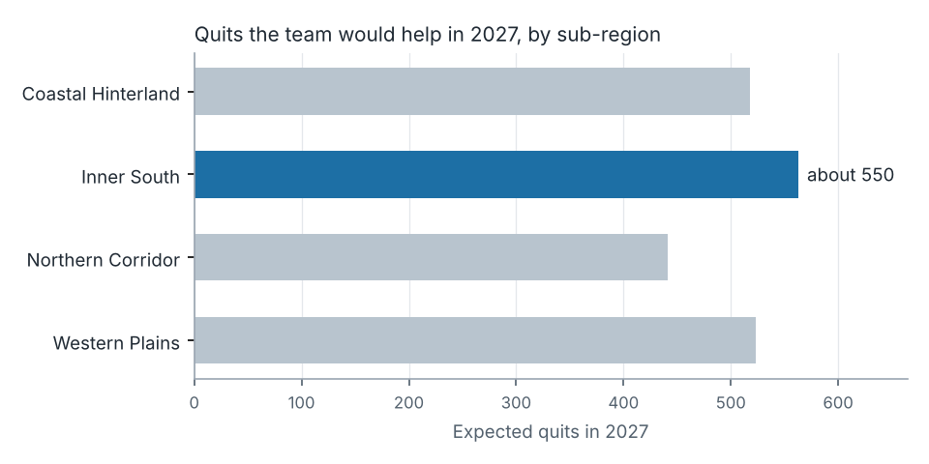

Points for the executive
- Eastern Shore's 2025 list was unusually fresh after its practices' 2024 recording drive, so its quits per listed patient overstate what a list with older records gives.
- A patient the team cannot contact at four weeks is counted as smoking, as the plan sets out.
- Quitline referrals, evening calling and talk time are in the workbook.

