Rothwell Bank | Economics | Initial claims preview | Thursday 8 October 2026
Initial claims, week ended 10 October: about 16,000
We expect the Unemployment Insurance Board to report about 16,000 initial claims for the claims week ended 10 October 2026 when it publishes the advance count next Thursday, 15 October, up from 11,695 in the week ended 3 October.
The week ended 10 October is the first claims week of the fourth quarter, the first in which claimants refused in July to September for want of base-period earnings can file again. How many of them do differs a lot from region to region. Over the past 50 quarter turns about one refused claimant in four has filed again in the first week in Western and about three in ten in Coastal and Island, where most of the refused are seasonal hotel and building workers whose last season now counts, against fewer than one in ten in the other five regions. This quarter's refusals sit where claimants come back: the third quarter left 30,182 monetarily ineligible determinations, about one and a half times a normal quarter, and 48.5 per cent of them were in Western, Coastal and Island, against about a fifth at a usual quarter turn.
Taking each region's refused claimants at its own rate, we put the claims filed again at 4,000 to 5,000, about nine tenths of them in Western, Coastal and Island, on top of 11,000 to 12,000 for the rest of the week. The national refusals taken at the national rate would put the week near 14,000, and a seasonal reading of past October first weeks lower still, because neither allows for where this quarter's refusals sit.
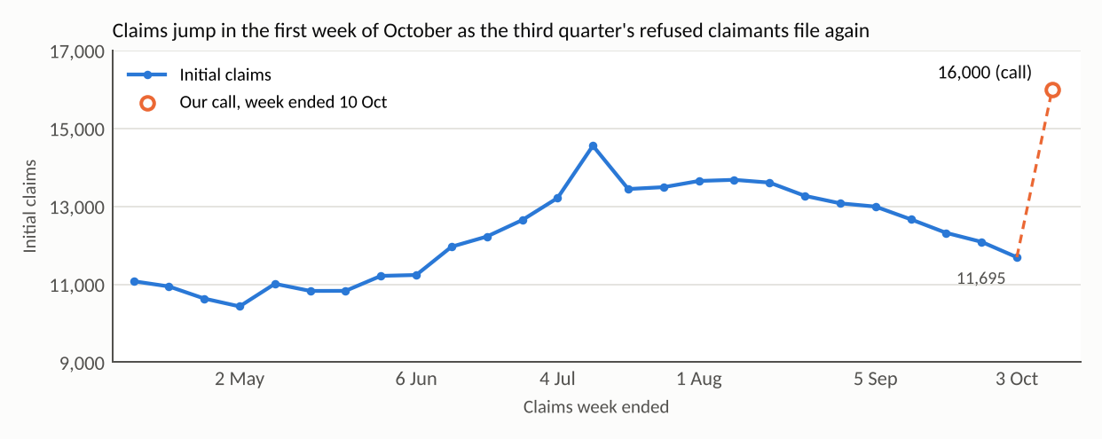
National initial claims by claims week, not seasonally adjusted; the week ended 3 October at its advance count. Initial claims are new and additional claims as the board counts them (technical notes, section 2.2). Source: Unemployment Insurance Board weekly claims and program statistics; Rothwell Bank Economics.
Layoffs already notified to the board for the rest of the year, by region, and the third quarter's change in claims by industry are in the attached workbook. Claims from construction and accommodation rose by more than the whole rise on a year ago; six of the other twelve industry groups are lower.
Stacey Baxter
Senior Economist, Rothwell Bank
This note is prepared by Rothwell Bank Economics for the bank's clients. It is not investment advice.

