Budget TNK 11.5 million for the match on the 2027 intake
To: the employment committee (copy: Erik Palm, director of finance). From: Caroline Hagman, reward and pensions. 13 November 2026.
Budget TNK 11.5 million for the employer's match on the staff we hire in 2027 (TNK 11,439,212 unrounded). About 1,600 of the 2,600 intake still with us on the December 2027 payroll will be contributing.
Automatic enrolment changes who has to act, not what people want. Under opt-in, 43 per cent of our hires eventually join, but they take their time: only by their twelfth payroll have 90 per cent of hires made any choice. From January every hire starts at 3 per cent and stays there until they choose, so those who will opt out leave gradually, and those who join at their own rate move off the default just as gradually.
We should not budget off the income protection cover's cancellations (about TNK 14.5 million): far fewer hires want to drop a 0.4 per cent cover than decline the plan, so its cancellation rate understates the opt-outs we will see.
Hospital | FY2027 match, TNK
Vindeholm Central Hospital | 3,800,000
Rendholm Hospital | 2,300,000
Askvik Hospital | 1,700,000
Ostervall Hospital | 1,400,000
Brannby Hospital | 1,200,000
Lidmark Hospital | 1,000,000
Group | 11,500,000
Hospital figures are rounded on their own and do not add to the group's. Source: HR history, Ledstrand register and the 2027 hiring plan, pulled 9 November 2026.
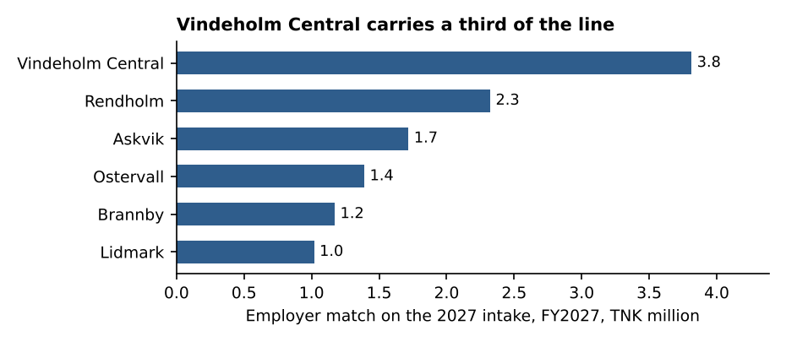
Basis: the approved 2027 hiring plan (3,025 requisitions) at the 2027 pay scale; leaving and choosing as our 23,822 hires since January 2019 did, all hospitals together. The workbook has the monthly profile, the curves and the 2026 actuals.

