WENMARSH REGIONAL HEALTH BOARD
Board meeting, 26 November 2026. For decision.
From: Andrea Davey, Head of Quality Surveillance. 2 October 2026.
External review of deaths after delayed escalation to critical care, 2027-28: place the review at Stennock
The Board is asked to place the 2027-28 external review at Stennock.
A year of review at Stennock could confirm 27 deaths as avoidable in the trust's own care. The trust that comes closest is Prideswick, at 15, so Stennock leads by 12 deaths.
The engagement is judged on the deaths its reviewers confirm as avoidable because of problems in the reviewed trust's own care, and the terms of reference count a trust's decisions about the use of its own beds and staff as part of that care (WRHB/26/097, sections 3 and 4). The placement rests on the latest four complete quarters, July 2025 to June 2026 (section 5).
Why Stennock
In the placement year 92 Stennock patients waited more than four hours for a level 3 bed and 27 of them died within 30 days of the decision to admit.¹ By the unit feed Stennock's unit was full at every minute of every one of those waits, which is consistent with the network's view that it is full every morning. The feed counts a bed as taken from the minute it is assigned, and on each of the 92 waits one or two of the beds counted as taken had been assigned earlier that day to Stennock's own planned surgical patients. The regional theatre extract shows that none of those patients had left recovery at the Stennock Treatment Centre when the waiting patient's decision was made; each left during the wait. At weekends, with no lists running, no Stennock referral waited more than four hours.
Those beds were staffed and empty, kept by Stennock for its own elective patients while its own emergency patient waited for a bed. Keeping a bed for a planned patient of its own is the trust's decision about the use of its own beds, and no bed bureau was involved. Under the methodology note every one of those 27 deaths therefore falls inside Stennock's own care, and they are the deaths a review can examine and confirm.
The pattern is not a one-year effect. Across the network's record Stennock has the most confirmable deaths in each four-quarter year (25, 28 and 27, against Prideswick's 14, 17 and 15), so the latest year is a fair guide to 2027-28.
Why not the others
The Chair's starting point, sending the reviewers to wherever the most patients die waiting, points to Lathingbury, which has the most deaths inside the remit (56 of 213). Lathingbury runs no level 3 beds, so each of its patients was waiting for another trust's bed, and a review there would confirm none of them as Lathingbury's own care. The programme screen Sharon Banks will present counts referrals waiting from receipt and is not the measure the engagement is judged on.
Trust | Deaths inside the remit | Confirmable in own care | What held the waits
Stennock | 27 | 27 | Beds in its own unit kept empty for Stennock's planned surgical patients, not yet out of theatre recovery, through each wait
Prideswick | 21 | 15 | 15 after waits beside its own empty staffed beds; 2 after waits through which its full unit took transfers the bed bureau placed; 4 with the unit full and no admission
Ristenholm | 44 | 2 | 35 after waits through which its full unit took transfers the bed bureau placed; 7 with the unit full and no admission; 2 beside an empty staffed bed
Lathingbury | 56 | 0 | No level 3 beds: every wait was for another trust's bed
Brackenford | 35 | 0 | Empty beds at 08:00 on most mornings, but full at every hour of each long wait, all of which began in the evening
Ellerdyke | 13 | 0 | No level 3 beds since April 2024
Tannerby | 10 | 0 | No level 3 beds
Pellowham | 7 | 0 | No level 3 beds since the winter beds closed in March 2024
All eight trusts | 213 | 44
Placement year, July 2025 to June 2026. Source: network referral record, unit feed, daily bed returns and transfer audit; regional data service episodes and theatre cases.
Prideswick is the real alternative. Its unit still holds weekend admissions until the on-call consultant intensivist has seen the patient on site, and 15 of its patients died after waiting beside its own empty staffed beds. That is a smaller yield than Stennock's, 12 deaths fewer, and the Board can raise the weekend rule with Prideswick through the network without a twelve-month review.
Ristenholm's unit gave beds to other patients during the waits behind 35 of its 44 deaths in the placement year, many of them planned transfers, which can read as Ristenholm putting other patients first. Every one of those patients was referred by a trust without level 3 beds, and the network's bed bureau allocates the bed for each transfer between trusts, so those waits are the network's capacity rather than Ristenholm's own decisions. Brackenford's morning returns show empty beds most days, which is what the network manager has in mind, but its unit was full at every hour of each of its long waits, all of which began in the evening.
The record behind the placement
Across the network's whole record, July 2023 to June 2026, 2,163 patients waited inside the remit and 629 died; the reviewers could have confirmed 148 of those deaths, 80 of them at Stennock. The figures by trust are in review_placement_workings.xlsx.
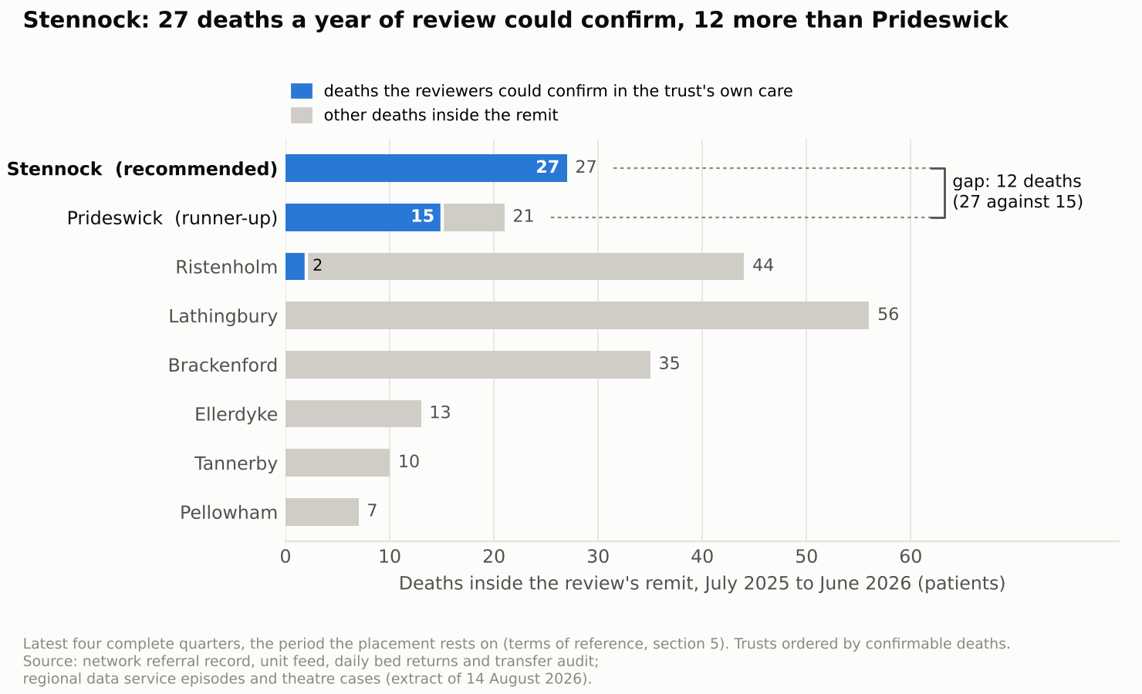
Recommendation
That the Board places the 2027-28 external review at Stennock, and informs the eight trusts in December 2026 as the terms of reference set out.
¹ Deaths are counted from the linked date of death on the regional data service episodes, within 30 days of the decision to admit. Death registrations reach the service within 14 days and the extract was taken on 14 August 2026, so the placement year is complete. Each patient is counted once.

