Corrisan Valley Air Quality District | Planning and Air Toxics
Seven fields without a tower qualify for the 2027 unleaded avgas round
To: Governing Board, meeting of 10 March 2027
From: Jeanette Steele, Air Toxics Planner
Copy: Tonya Krause, Grants Program Manager
Date: 12 February 2027
Subject: 2027 Unleaded Avgas Transition Grants, qualifying fields on the 2026 aircraft lead inventory
Seven of the 24 public-use fields without a control tower qualify for the 2027 round: Thornacre Regional (T13, 22 kg), Ambrell County Airport (A71, 21 kg), Lanthorne Field (L08, 16 kg), Umber Creek Airport (U44, 15 kg), Wickrow Airfield (W33, 14 kg), Orrin Flats Airport (O16, 14 kg) and Fennick Airpark (F37, 14 kg). Each emitted 12.5 kg or more of lead from piston-engine aircraft in 2026 under method CVAQD-AQ-17, Revision 3, which the round's guidelines (section 2.2) make the test. The highest field below the line is Pellow Municipal at 11 kg.
How the operations the network missed were placed. The receiver network records every operation of an aircraft that broadcasts ADS-B Out and none of one that does not. At the ten fields with a count (the six towers and the four fields the District had counted through 2026) the counts exceed what the network recorded by 23,376 operations, and those fields have 338 based piston airplanes that the network never recorded anywhere in 2026: 69.2 operations a year for each. The fields without a count were completed the same way, 69.2 operations for each based piston airplane the network never recorded there, at 1.625 g each (method section 3.2). The airplanes that never broadcast are not spread evenly: the vintage fields keep most of them and the flight-school fields almost none, so the network hears 82 per cent of the counted fields' operations overall, 56 per cent at Dunmarsh Airport and 99 per cent at Lanthorne Field.
Scaling every field's recorded operations by that 82 per cent instead would have qualified Kestrel Ridge Airpark, Pellow Municipal, Saltry Field and Tavish Aero Field and left out Orrin Flats Airport, Umber Creek Airport and Wickrow Airfield.
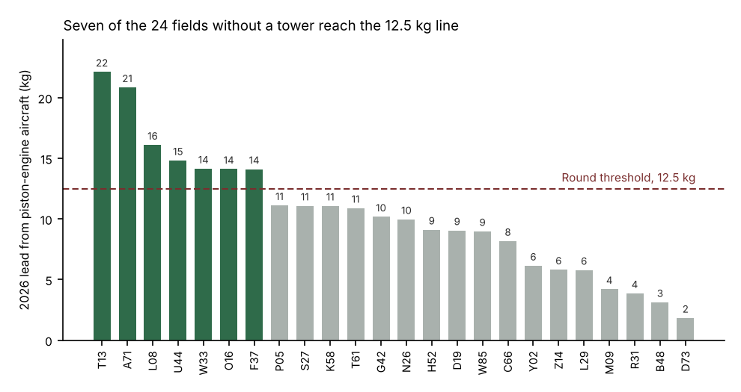
Lead by field, 2026, kilograms. Qualifying fields in green. Field figures in corrisan_2026_field_piston_lead.csv.
The towered fields. They are outside the round but complete the 2026 inventory; their operations are the network's recorded piston operations, each assigned to the aircraft that flew it, and the towers' counts beyond what the network recorded. Where an owner moved an N-number to a turbine in 2026, the piston airplane kept flying on its old address until the turbine arrived, weeks after the Registry's date, and those operations are counted as its own.
Field | LocID | Piston operations, 2026 | Lead, 2026 (kg)
Halwick Municipal | HWK | 17,600 | 22
Corrisan Valley Regional | CRV | 9,900 | 18
Ostrey Field | OSY | 19,400 | 23
Varnell County Airport | VNL | 12,200 | 16
Kesterly Field | KTY | 13,600 | 16
Dunmore Municipal | DMR | 7,900 | 13
Sources: ADS-B field events export of 8 January 2027; FAA register extract of 1 February 2027; tower daily counts; the 2026 count studies; the state's 2027 based aircraft validation.
Notes. Operations as a tower counts them: a takeoff or a landing is one, a touch-and-go two (method section 2.1). The year is 2026 in Pacific time. Lead is rounded to the whole kilogram and operations to the nearest hundred from unrounded totals; qualification is judged on the unrounded lead. An airplane that changed its N-number during 2026 is counted as recorded when the network heard either address.

