Lot ZC2638: reserve 400 Model K packs at release
To: Christiana Harloff, Product Finance Controller, Notebook Division
Copy: Frieder Henschel, Battery Reliability Lab
From: Product Finance, Notebook Division
Date: 15 October 2026, for the release on Friday 16 October
Subject: Warranty reserve for the Model K packs of Zelvora lot ZC2638 (FIN-RS-04)
Book a reserve of 400 packs for the 7,200 Model K packs built from lot ZC2638.
The expected number below 80 per cent of rated capacity within 600 cycles is 398.9, 5.5 per cent of the packs. The 120 cells of the release test predict a chance of 2.4 per cent for a cell at RL-3's validation error. A pack falls below 80 per cent with its weakest cell, and the line builds its packs from one formation tray at a time: 7,063 of the 7,200 packs are three tray-mates, 136 take two cells from one tray and one from another, and one pack has a cell from each of three trays.
Most of RL-3's error is the tray's, not the cell's. On the twenty finished lots, 2,373 cells followed to 80 per cent, the error of the log life has a standard deviation of 0.160 shared by a tray's cells and 0.086 of each cell's own: 78 per cent of its variance sits at the tray. The first 100 cycles do not show it (the release test's own predictions carry almost no tray structure); only whole trays cycled to the end do. The three cells of a pack therefore succeed or fail largely together, so a pack's chance is the chance, over its tray's shared error, that any of its cells falls short. Compounding the cell chance over three independent cells would give 7.1 per cent and 514 packs.
Cost of a capacity replacement at the repair partners, October 2025 to September 2026
Partner (region) | Replacements | Average cost (EUR) | Of which return freight (EUR)
Dauvergne Réparation (FRB) | 99 | 99 | 4.12
Tolley Marsh Repair (UKI) | 81 | 102 | 6.10
Ljungqvist Service (NOR) | 58 | 112 | 9.70
Ferrucci Assistenza (SOU) | 79 | 96 | 5.12
Invoice line at treasury's month-end rate for its service period, the battery's share of its consignment's carrier charge, the service pack at standard cost. The DACH depot's internal cost is in the cost sheet.
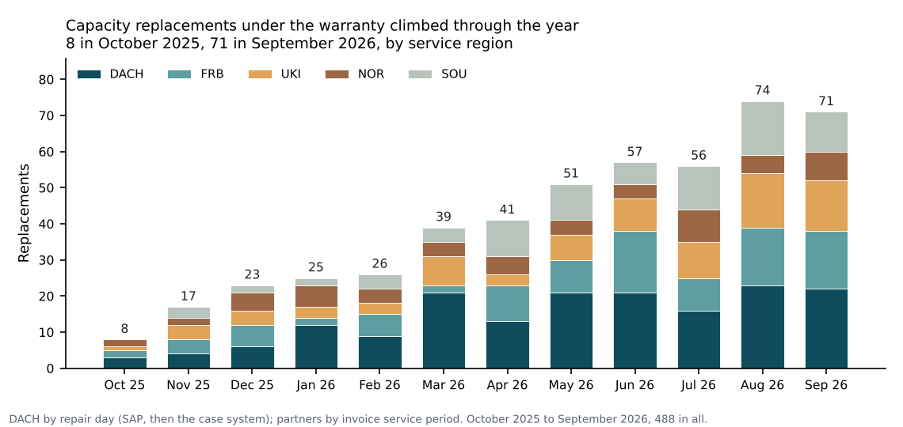
488 capacity replacements under the warranty in the twelve months, 71 in September 2026. z2638_warranty_reserve.xlsx has the reserve's working, the partners' costs and the monthly table.
Packs: every Model K pack the battery plant built from the lot's cells by the release day, as FIN-RS-04 clause 2.2 counts them, from the line genealogy. Cycle lives are on QP-3, which the pack's gauge counts as its cycles (clause 3.3). Tolley Marsh Repair's March 2026 invoice is taken as reissued (TM-2603-R1).

