UTI pathway 2027-28: where the two pharmacists go
To: Clinical Director From: Antimicrobial Stewardship Lead 13 January 2027
Placement: one pharmacist to Morrow Cross and one to Tamsey from 1 April 2027. On the 2026 basis, moving their first courses on other antibacterials to nitrofurantoin would have stopped about 70 and 70 mismatched first courses. Kesterby is the runner-up at about 50.
Each antibacterial's chance of meeting a resistant organism is read on the urine cultures practices sent at the first course's own consultation in 2024 to 2026 (4658 cultures): nitrofurantoin 5%, pivmecillinam 13%, fosfomycin 10%, trimethoprim 15%. Most of the laboratory's other urines from these women were sent after a course had not worked, and those over-represent the organisms the federation's current first courses miss, nitrofurantoin's above all, so they are not used for the chance a first course runs.
Network | 2026 first courses on other antibacterials | Mismatched courses stopped (nearest 10)
Morrow Cross | 1123 | 70
Tamsey | 1098 | 70
Kesterby | 543 | 50
Upper Lode | 610 | 40
Ashwell Vale | 521 | 40
Stanbridge North | 1192 | 30
Brackenholt | 420 | 20

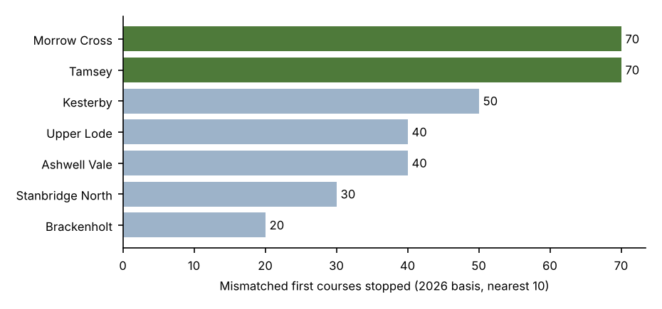
Detail by antibacterial, and the 2026 organisms in older women and men for the pharmacists' wider advice, are in uti_pathway_placement_2027-28.xlsx.

