NHS Kestrel Vale Integrated Care Board: Board, 5 November 2026. Item 9.
Hypnotic deprescribing team: place it in Saltreach Coast for 2027
Presented by Julia Clayton, Chief Pharmacist. Prepared by Glenn Pearce (Kestrel and Wold Commissioning Support Unit). Purpose: for decision.

Recommendation
Place the deprescribing team in Saltreach Coast from January 2027. On the deprescribing policy it will avoid 19 emergency admissions for a fall in 2027. Hethermoss is the runner-up at 15, 4 fewer.

Why Saltreach Coast
The team takes 45 in every 100 current users off the drug from 1 April, and each one it takes off stops running the extra risk of a fall that the drug carries. That extra risk depends on how long the patient has been taking a benzodiazepine or Z-drug: the policy puts it at 1.8 times the rate of a patient not taking one until two years after they first started, and 1.1 times after that. So the team avoids most where the current users started most recently, not where there are most of them.
Saltreach Coast has 5,034 current users, and 1,888 of them first started on or after 1 April 2025, more than in any other locality. Corvenham Central has the most current users (6,812) but only 477 started that recently; most have taken the drug for years and carry little extra risk now.
Each patient's first start is the start of their first repeat template, traced back through every re-authorisation, and for Mill Road Group Practice in Quenford Rise through the templates exported from its previous clinical system, because its July move re-created every active template with the date of the move. The dispensing extract cannot date a start: it begins on 1 April 2026, so everyone already on the drug appears to start that month.
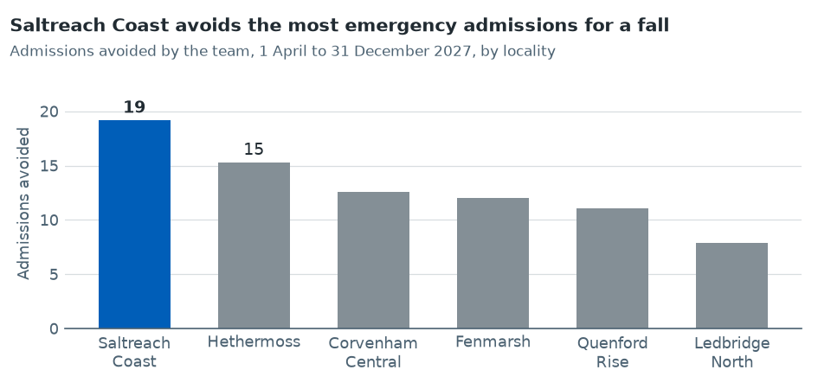

The six localities
Locality | Current users | First started since April 2025 | Admissions avoided
Saltreach Coast | 5,034 | 1,888 | 19
Hethermoss | 3,611 | 1,155 | 15
Corvenham Central | 6,812 | 477 | 13
Fenmarsh | 4,987 | 698 | 12
Quenford Rise | 4,583 | 642 | 11
Ledbridge North | 3,226 | 452 | 8
Current users: patients aged 65 or over on 1 January 2027 with a benzodiazepine or Z-drug dispensed between 1 July and 30 September 2026 (policy MO-17, section 4). Admissions avoided are rounded to whole admissions.
Sources: dispensing extract April to September 2026; repeat templates as at 1 October 2026; Mill Road Group Practice previous-system template export; practice register; policy MO-17.

Falls burden
The placement workbook gives each locality's emergency admissions for a fall in 2025-26 by age band, the bed-days they used and the readmissions within 30 days, on the falls dashboard's version 2 definitions.

Risks
The figure assumes the pilot's 45 in 100 holds in Saltreach Coast and that the policy's rate ratios hold for its patients. If fewer come off, the number avoided falls in proportion in every locality, so the order does not change.

