The 2027-28 levy of £7,416,300 falls 50.7 per cent on Keldmere, Ravenwick and Snelgarth, whose residents use the parks most
Apportionment under resolution 14/2026. Report of the Head of Finance. For decision.
Recommendation
That the Authority approves the levy on the member councils for 2027-28 as set out in the table below, a total of £7,416,300, and notifies each council of its levy by 15 February 2027.
Member council | Residents 16+ who visited, 2025-26 | Share | Levy 2027-28 (£) | Levy 2026-27 (£) | Change (£)
Keldmere District Council | 45,500 | 16.9% | 1,252,070 | 684,075 | +567,995
Ravenwick Borough Council | 55,900 | 20.8% | 1,540,108 | 916,786 | +623,322
Snelgarth District Council | 35,200 | 13.1% | 968,963 | 583,356 | +385,607
Larkstead Borough Council | 26,000 | 9.7% | 716,993 | 1,132,547 | -415,554
Grinbury District Council | 26,900 | 10.0% | 741,438 | 785,911 | -44,473
Hornmere District Council | 24,500 | 9.1% | 675,709 | 994,247 | -318,538
Chaldale District Council | 19,900 | 7.4% | 547,403 | 528,693 | +18,710
Wendstow District Council | 17,900 | 6.6% | 492,870 | 845,501 | -352,631
Ferncote Borough Council | 17,500 | 6.5% | 480,746 | 719,684 | -238,938
Total | 269,300 | 100.0% | 7,416,300 | 7,190,800 | +225,500
Residents are estimates from the 2025-26 visitor survey, shown to the nearest hundred; shares, levies and totals are worked from the unrounded estimates, so the rounded residents may not add to the total, and each levy is rounded to the pound (resolution 14/2026, paragraph 5). The 2026-27 levy was apportioned by mid-2024 population (Appendix B to the item 7 papers).
How each council's residents were counted
Resolution 14/2026 apportions the levy by the number of each council's residents aged 16 and over who visited at least one of the six parks between 1 April 2025 and 31 March 2026, each counted once however often they came, as estimated from the visitor survey. The survey did not set out to count people. Its interviewers stood at each park's main exit on sampled days and approached every eighth adult leaving, so it is a sample of visits: a Keldmere resident who walks a dog in Brathden Woods most mornings passes the survey line two hundred times a year and is two hundred times as likely to be interviewed as a Larkstead family who come once. The contractor's weights expand each of the 4,470 interviews to the adult visits it stands for in its park, season and day type.
To count people, each interview is weighted by its expansion weight divided by the number of visits the respondent said they had made to the six parks in the last 12 months, including the day of the interview, every park counted because the survey could have met them leaving any of them. A respondent who came twice then stands for half as many people as their weight stands for visits, and one who came two hundred times for a two-hundredth: across everyone the visit sample can reach, each resident is counted once. On that basis 269,300 of the nine councils' residents aged 16 and over visited in 2025-26, 136,600 of them from Keldmere, Ravenwick and Snelgarth.
Two shortcuts give a different split and are not used. Summing the weights by council counts visits, not residents, and would put 85.1 per cent of the levy on the three valley councils. Dividing each council's visits by its respondents' average visit count looks like a count of people, but in an exit survey that average is weighted towards the people who come most, because they are the ones most often interviewed; it overstates how often residents come, most where everyday walkers and occasional visitors mix, and would put only 25.0 per cent on the valley councils. Dividing by the visits to the park where the interview took place alone counts a resident who walks in two parks once at each, 55.5 per cent on the valley councils.
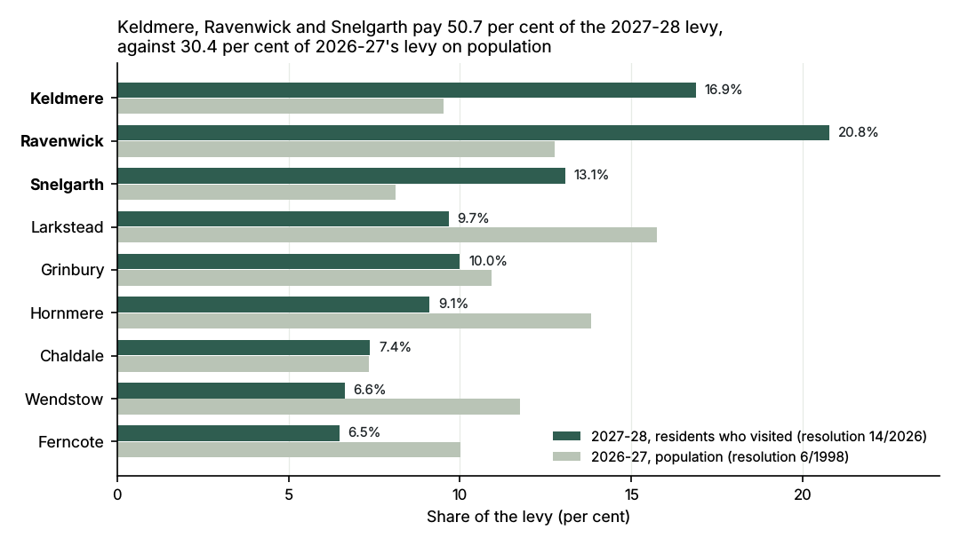
Interviews by home area: 3,973 with residents of the member councils, 473 with visitors from elsewhere (not counted, paragraph 6) and 24 whose home could not be placed (not counted, paragraph 4).
Car parks, 2025-26
Parking income offsets the levy requirement, and the car-park counts are the base from which the survey's visits are expanded. For the four charging parks:
Park | Pay machines, net of VAT (£) | Parking app, net of VAT (£) | Paid in all, net of VAT (£) | Vehicles entered
Gorthfield Country Park | 210,344 | 228,969 | 439,313 | 171,505
Daskbeck Water Park | 210,653 | 332,472 | 543,124 | 134,156
Lockshaw Moor | 255,553 | 194,207 | 449,759 | 166,487
Thruscote Hall | 180,216 | 220,545 | 400,761 | 126,385
Total | 856,766 | 976,192 | 1,832,957 | 598,533
Machine takings are each ticket once (three machines re-sent several days' tickets with a later upload), at the park where the machine then stood (PM-2103 was in Gorthfield's main car park until 1 September 2025), less VAT at 20 per cent. The app provider states parking income without VAT. Vehicles are counter entries: the Water Park's loop installed on 18 August 2025 counts vehicles in and out and is halved; Gorthfield's lakeside entrance is counted once while its old and new counters ran side by side in February 2026; counter C-07 counted at Thruscote Hall until it moved to Lockshaw Moor on 14 October 2025. Rows may not add to the total by a pound.
The 2025-26 levy at 31 March 2026
Member council | Levy 2025-26 (£) | Paid by the due dates (£) | Paid late, by 31 March 2026 (£)
Keldmere District Council | 664,285 | 498,214 | 166,071
Ravenwick Borough Council | 890,351 | 667,764 | 222,587
Snelgarth District Council | 566,832 | 566,832 | 0
Larkstead Borough Council | 1,097,888 | 1,097,888 | 0
Grinbury District Council | 763,277 | 190,819 | 381,638
Hornmere District Council | 964,788 | 723,591 | 241,197
Chaldale District Council | 514,387 | 382,336 | 128,596
Wendstow District Council | 821,365 | 616,024 | 205,341
Ferncote Borough Council | 699,227 | 524,421 | 174,806
Total | 6,982,400 | 5,267,889 | 1,520,236
Seven councils paid at least one instalment after its due date by 31 March. Snelgarth and Larkstead paid every instalment on time; Grinbury's fourth instalment reached us on 8 April 2026, and Chaldale paid its third instalment at its 2024-25 amount, leaving £3,455 unpaid. Payments are dated by the day the bank credited them: the cash book posts each receipt from the bank's statement the next working day, so a payment made on its due date shows there a day late, and the fourth instalments paid on 31 March fall in April's postings, outside the finance system's 2025-26 receipts, and are taken from the bank's report. Where a council's payment run paid a sundry invoice with an instalment, the receipt counts once and the instalment at its own amount.

