Larkhaven Health, Pharmacy Quality and Formulary
To: Formulary Quality Group
Date: 20 July 2026
Subject: Third-quarter laboratory re-test, levetiracetam 500 mg tablets
Recommendation: send Tessard to the contract laboratory. Its patients had 4 more qualifying visits per 1,000 patient-months than the same patients would have had on tablets releasing like Levaril, above the 2.0 referral bar in MS-12 3.1.
Halvorne shows the largest raw excess, but it sits in each patient's first supply of its new pink tablets, filled as the Fort Wayne stock reached each distribution centre between December and May. The same excess follows every change in what a patient's tablets look like, Pellbrook patients moved onto the pink tablets and back during the Pellbrook backorder included, and it does not follow a move between tablets that look alike. With that first supply held as it was, only Tessard is above the bar, and its excess runs through every fill.
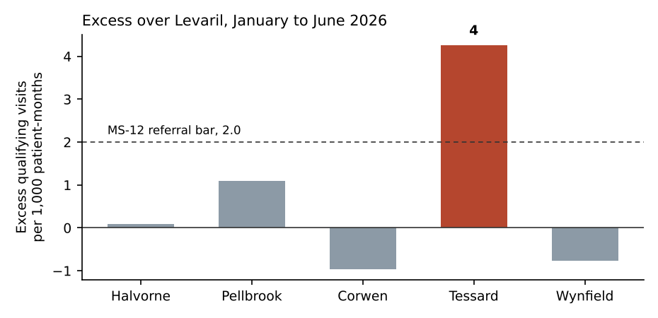
Source: paid claims net of reversals, both hospital feeds dated in Pacific time, transfers counted once (MS-12 2.3 to 2.6).

