To: The Board
From: Caitlin Holland, Manager, Review Program
Date: 12 February 2027
Subject: Review Program horizon for the term from 1 July 2027 (program terms, clause 4)
Set the horizon at 60 years after first exposure
Recommendation: that the Board set the Program's horizon for 2027-2031 at 60 years after first exposure. On the register, 93.3% of the workforce's mesotheliomas are diagnosed within 60 years, against 85.1% within 55 years, so 60 is the shortest five-year step that reaches the nine in ten that clause 4.2 asks for.
Setting (years after first exposure) | Mesotheliomas diagnosed within it | Members reviewed in 2025-26 still inside it on 1 July 2027
40 | 32.1% | -
45 | 53.9% | 355
50 | 72.4% | 1,457
55 | 85.1% | 3,272
60 (recommended) | 93.3% | 5,286
65 | 97.4% | 6,685
70 | 99.1% | 7,340
Source: Fund mesothelioma register as closed for 2025-26, 5,271 cases among workers first exposed before 1 January 1986; members and bookings from the Program's booking system.
Household, environmental and unexposed cases on the register, and workers first exposed in 1986 or later, are outside the workforce (clause 2.1). The setting is read from the unrounded shares.
How the shares were read
The register only holds a mesothelioma diagnosed between 1 July 2004 and 30 June 2026. So each worker's latency can only reach it inside a window that their first exposure fixes: a worker first exposed in 1950 appears only if diagnosed 54 to 76 years later, one first exposed in 1980 only at 24 to 46 years. Taken as they stand, the register's latencies miss the short latencies of the early workforce (diagnosed before the Fund began) and the long latencies of the 1970s and 1980s workforce, which are still to come; most of the workforce started in the 1970s, so the second gap is the bigger one. Read straight off the register, 92.7% of cases fall within 55 years; admitting cases only from the Fund's start gives 95.9%. Both put the horizon at 55 years.
The shares above weight every case by the chance that its own window catches a latency, estimating the latency curve and those chances together (the nonparametric maximum likelihood estimate for data seen between two dates; no curve shape is assumed, per clause 4.4). Years after first exposure run from the first day of the earliest period of work the exposure assessment marks as exposed to the day of diagnosis, at 365.25 days a year (clause 4.3).
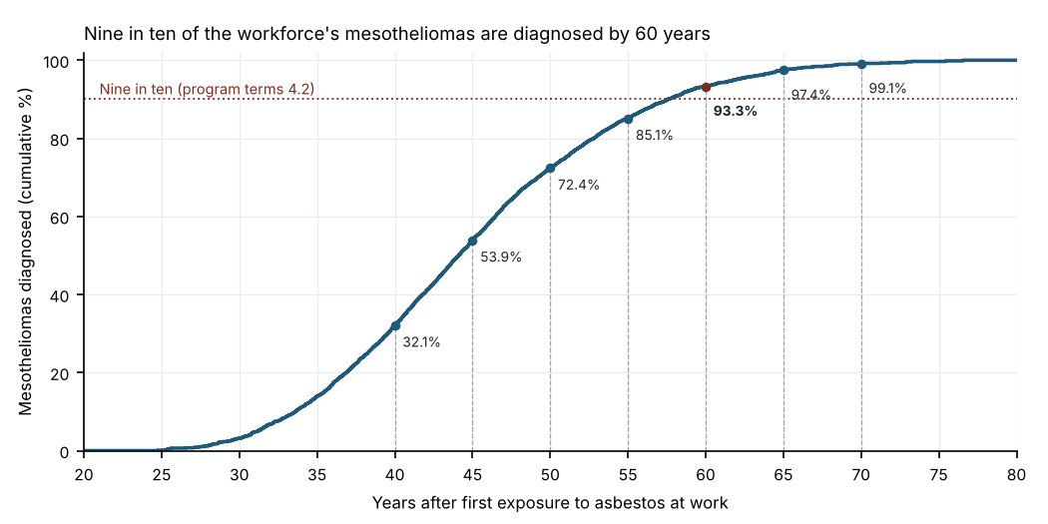
For the term's costing
Of the members reviewed in 2025-26, 5,286 would still be inside a 60-year horizon on 1 July 2027 (3,272 inside 55 years). The Mobile Review Unit held 1,923 reviews across its fourteen circuit towns in 2025-26, from 399 at Corrinbar to 55 at Wennobank; the workbook has every town.
Attachments: review_horizon_workbook_2027.xlsx (settings, members by setting, unit reviews by town).

