Kaimai Building Society | Term Deposits
January to March 2027 maturity calls: book 5,500 agent-hours with Harbourline
To the Deposits Committee (chair Stuart Waller, Head of Deposits), for its meeting on 17 November. From Hazel Johnstone, Term Deposits Product Manager. 5 November 2026.
Book 5,500 agent-hours with Harbourline for the January to March 2027 list: 1,500 for the deposits maturing in January, 2,000 for February and 2,000 for March. The block is due with Harbourline on Friday 20 November; it is payable in full, and hours beyond it cost the block rate plus 35 per cent.
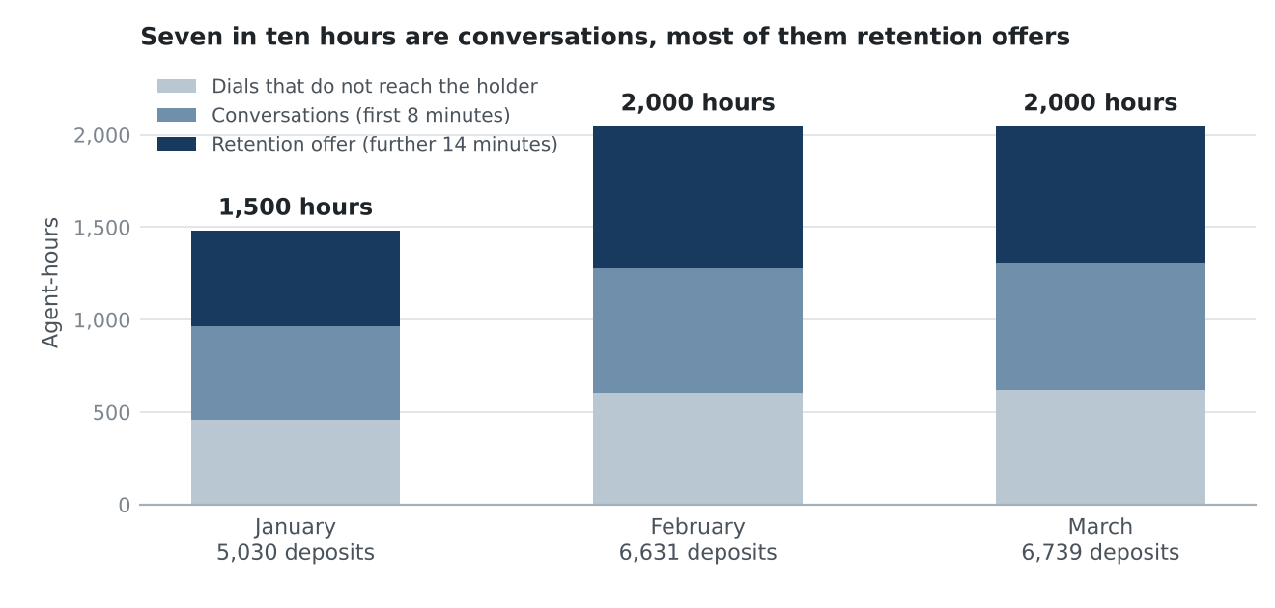
Agent-hours to book by maturity month. Source: TDR-2027Q1 list and contact points at 2 November 2026; Harbourline dial logs and close-outs for the seven campaigns closed since January 2025; SOW HCS-KBS-2025-01 schedule 2.
Why the block is larger per deposit than any campaign so far
10,735 of the 18,400 deposits on the list are four-year deposits opened at 5.65 per cent in January to March 2023. They reinvest at the 3.15 per cent four-year rate ALCO has approved for the quarter, a drop of 2.50 points. In every campaign since January 2025, whether a holder Harbourline reached said they meant to move the money, and so went through the 22-minute retention offer, followed the drop from the deposit's rate to the rate it rolled onto: 0.1 per cent of conversations where the rate rose, 92 per cent at drops of 2.5 points or more. The four-year deposits we have called so far were opened in 2021 and 2022, when rates were low, and few of their holders took the offer. On this list about 62 per cent of an expected 14,000 conversations should go to the retention offer, against 33 per cent across the seven campaigns.
How the hours are built
Harbourline bills 1.5 minutes for each dial that does not reach the holder, 8 for each conversation and 22 for each retention-offer conversation. Dialling per case comes from the seven closed campaigns for each mix of callable numbers, after washing the list's numbers against the do-not-call register at the cut: 460 deposits have no callable number and will get the maturity letter only. 95.5 per cent of deposits with a callable number have reached release in past campaigns; the rest gave us instructions first.
In the workbook
td_booking_q1_2027.xlsx carries the booking by month with its basis, what each campaign since January 2025 kept on term deposit 30 days after maturity, and the principal maturing across the book in each month of the quarter with the part the list does not cover.
Hours are Harbourline's billed agent-minutes under schedule 2, not rostered time. Each month is rounded from its own forecast to the nearest 250 hours, as procedure v4 rounds the block.

