MEMORANDUM
To: Board of Directors, through the Finance and Audit Committee
From: Olivia White, Manager, Ground Transportation Finance
Date: 16 October 2026
Subject: 2027 taxi pickup fee under By-law GT-3, section 4

Set the 2027 taxi pickup fee at $6.50, down from $6.75 in 2026.
The 2027 Ground Transportation Program budget assigns $535,027 to the taxi pickup fee. Under FP-07 the budgeted pickups are 2025's 74,753 fee-liable pickups restated to the forecourt rank that returns on 1 January 2027, 84,000 pickups. At $6.50 a pickup they recover the amount with about $10,000 to spare; at $6.25 they would fall about $10,000 short.
What the restatement removes
Since 4 November 2024 taxis have loaded at the temporary rank on the P2 Level 2 road. The Airport Line opened the same morning, so the fall in pickups that November is two changes at once: the rank, which goes in 2027, and the line, which stays. FP-07 restates only the rank (a taxi loading arrangement), so its effect has to be read apart from the line's.
Drop-offs at the departures roadway never used the rank, but the line took riders in both directions on trips to and from the zones its stations serve (Downtown Central, Midtown, University and Commerce Park). Those zones send the airport most of its drop-offs but take under half its pickups, so the line cut drop-offs almost as much as pickups overall. Within the station zones the ratio of pickups to drop-offs was 10.6 per cent lower in 2025 than in the twelve months before the move, and within the other zones 11.0 per cent lower: the rank cost 11 per cent of the pickups 2025 would have had at the forecourt.
Two quicker readings give other fees. Taking the whole 22 per cent fall in pickups as the rank's effect restates the line away as well and gives $5.75; setting all pickups against all drop-offs credits the rank with only 3 per cent, because the drop-offs carry more of the line's zones, and gives $7.00.
How firm the fee is
$6.50 is the lowest 25-cent step that recovers the amount (By-law GT-3, s.4) for any rank effect from 9.2 to 12.7 per cent of the restated pickups; just below that range the fee would be $6.75, just above it $6.25.
Monthly trips
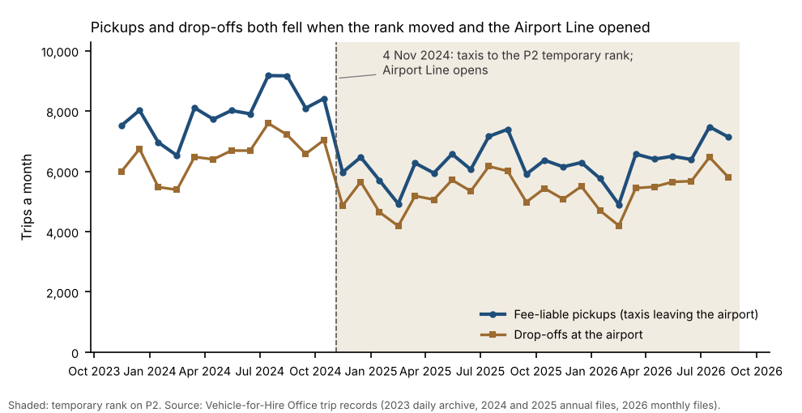
Notes
1. Base-year pickups are read from the Vehicle-for-Hire Office's final 2025 annual file (FP-07 4.4); no traffic growth is assumed (FP-07 4.2). Restated pickups are shown to the nearest thousand; the fee is worked on the unrounded figure.
2. The brokerage ledger (velmont_taxi_fee_ledger_2025_2026.csv) bills each pickup to the brokerage the taxi belonged to when the trip began (By-law GT-3, s.3(2)): 2025 from the annual file with the Office's affiliation register, 2026 from the monthly files with re-sent and voided records taken out.

