COLDMERE CANALS TRUST Water Management
To | Water Management Group, for the trustees' capital meeting of 10 December 2026
From | Katy Wilkinson, Water Resources Planner
Date | 6 November 2026
Subject | Back-pumping scheme 2027/28: siting
Reference | WM/BP/26-07

Kelsby summit should take the 2027/28 back-pumping scheme
Kelsby's two summit locks drew 1460.8 Ml from the summit pound by filling their chambers between 1 April and 31 October 2026, 274.3 Ml more than Tilsey (1186.5 Ml) and well clear of Harnock (1140.8 Ml). On the siting basis the Water Management Group agreed in September (programme paper 3.1 to 3.4), the scheme goes to Kelsby.

What each summit drew
A summit pound gives up a lockful each time one of its summit locks is filled: for every boat or pair of boats going up, and for boats going down whenever the boats before them left the chamber empty. I followed each summit lock's chamber through the season from the counter network's export, with the Tilsey keepers' log for the three weeks Tilsey Top Lock's camera was out of service.
Harnock carries the biggest lockfuls on the network, but its broad chambers take two boats side by side and most of its crews share: Harnock Top Lock's 7,005 boat movements made 4,995 chamber cycles and Steward's Lock's 6,501 made 4,637. Kelsby's narrow chambers take one boat at a time, short cruisers apart, and the Kelsby Ring and the hire base at the wharf send most crews up Kelsby Top Lock and down Wharf Lock, so each chamber is usually set against the next boat. Tilsey carries the most boats, but its flight is worked in turn, with boats going down taking the chamber the last boat up left full.
Summit lock | Boats up | Boats down | Fillings | Water drawn (Ml)
Kelsby Top Lock | 5,289 | 1,354 | 5,379 | 780.5
Wharf Lock | 1,150 | 5,079 | 5,189 | 680.3
Harnock Top Lock | 3,538 | 3,467 | 3,248 | 605.4
Steward's Lock | 3,217 | 3,284 | 3,047 | 535.4
Tilsey Top Lock | 4,662 | 4,706 | 5,807 | 601.6
Engine Lock | 4,692 | 4,637 | 5,902 | 584.9
Source: LockCount export of 3 November 2026 with 949 repeat reads and 1,476 unpowered craft left out; lockfuls from the 2025 chamber survey.*
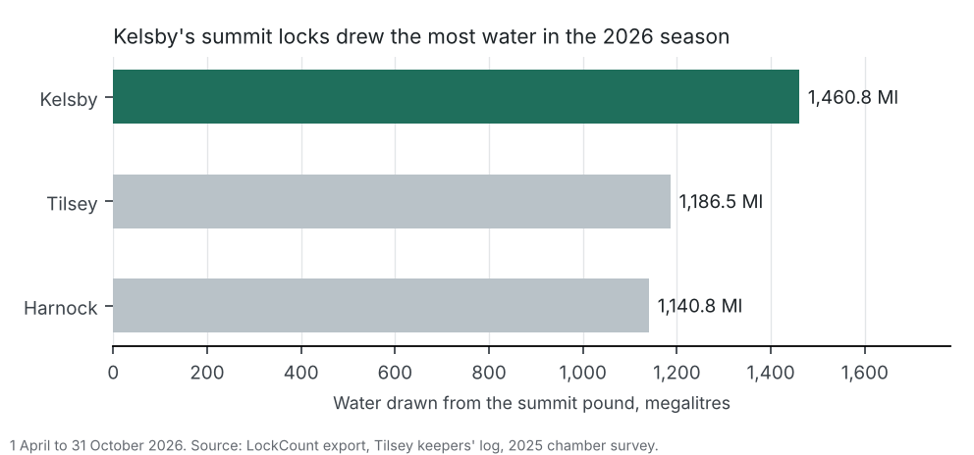

The summit water budget
Over the same season the reservoirs released 2246.9 Ml from Lower Kelsby (topped up with 527.2 Ml from Upper Kelsby), 6859.1 Ml from Coldmere and 1090.6 Ml from Tilsey. Divided at Fox Bridge, that gave Kelsby summit 2246.9 Ml, Harnock summit 4462.5 Ml and Tilsey summit 3487.2 Ml. Abstraction agreements took 54,378 m3 from Kelsby, 508,030 m3 from Harnock (most of it the trout farm's through-flow) and 54,682 m3 from Tilsey.

For approval
That the trustees approve Kelsby summit as the site of the 2027/28 back-pumping scheme, with detailed design from January 2027. The figures by lock, reservoir and agreement are in summit_water_2026.xlsx and the day-by-day return in summit_lockage_return_2026.csv.
* A lockful is the chamber volume in the 2025 chamber survey (programme paper 3.3); the 1951 schedule's dimensions in feet and inches are not used.

