To: Value Analysis Committee (chair: Richard Hart, Director of Value Analysis)
From: Sara Gray, orthopaedic outcomes analyst
Date: 23 April 2027
Re: Hip agreement renewal, 1 July 2027: constructs under Policy VA-07, section 4
Three of the six hip constructs meet the ten-year revision bar
Keep Askvane/Quarvel, Holbrin/Pellvoro and Askvane/Pellvoro on the agreement. Take Edvalt/Kelvarne, Edvalt/Pellvoro and Kalvoran/Morvenne off it for primary operations; under section 4.5 their components stay available for revisions.
Construct | Revised by 10 years | Policy VA-07, 4.2 | 2026 hips, all three hospitals
Askvane/Pellvoro | 3.5% | Stays | 211
Askvane/Quarvel | 3.7% | Stays | 165
Holbrin/Pellvoro | 4.1% | Stays | 317
Edvalt/Pellvoro | 5.7% | Comes off | 90
Edvalt/Kelvarne | 7.0% | Comes off | 75
Kalvoran/Morvenne | 7.6% | Comes off | 151
Source: Brennick Valley Joint Registry extract of 31 December 2026, Kaplan-Meier, deaths and moves out of Wisconsin censored; 2026 hips from the perioperative implant log.
Most of the Edvalt constructs' ten-year evidence is hips replaced before the registry began in January 2018. The registry entered those hips at the patient's first registry clinic visit, between 2018 and 2021, so a hip revised before its visit never reached the registry, and the curves below count each of them at risk only from the visit. Clocked from the operation instead, the years before the visit enter as revision-free and both Edvalt constructs come out near 3 per cent (3.1 and 3.2).
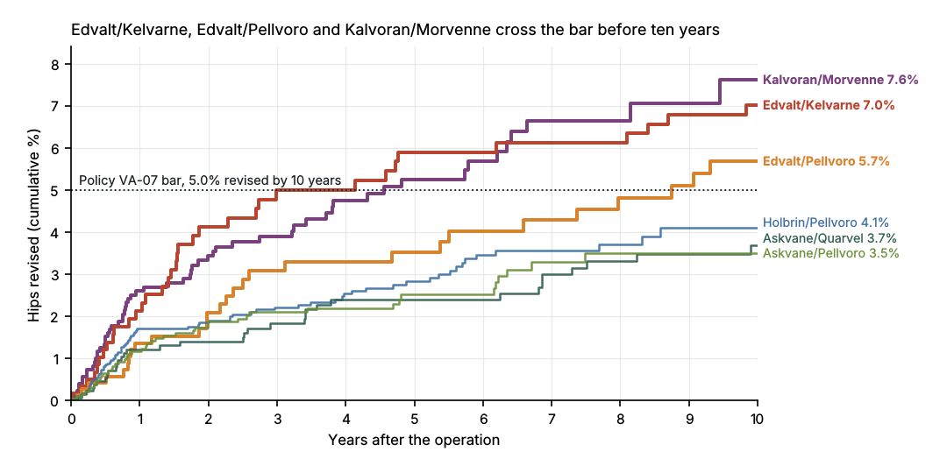
For the renewal's volumes: the three hospitals put the six constructs into 1,009 primary total hips in 2026 (Brennick Valley Medical Center 353, Tollefson Lake 208, Kittelstad 448); the scorecard has them by construct and hospital. 28 of those hips are not on the registry (Brennick Valley Medical Center 12, Tollefson Lake 5, Kittelstad 11).
Death dates the state linkage gives as month and year only are taken as the 15th; the 1st or the last day of the month changes no figure at one decimal. Ten years is 3,652.5 days.

