Corvane Pharmacy Solutions
Anticonvulsants proposed for the 1 July 2027 State MAC update
To: Sonya Burton, Pharmacy Director, Department of Health Coverage
From: Carrie Arellano, MAC Pricing Lead
Copy: Todd Allen, Account Director
Date: 30 April 2027
Re: Proposal under Attachment C, section C.4

We propose Anticonvulsants (C107) for the State MAC list from 1 July 2027. Its ingredient spread over fills from April 2026 to March 2027 was $43,000, the largest of the twelve candidate classes; antipsychotics were next at $30,000.
Candidate class | Claims | Ingredient cost paid | Ingredient spread
Anticonvulsants | 40,210 | $233,380 | $43,000
Antipsychotics | 34,285 | $211,586 | $30,000
Dementia agents | 11,949 | $102,664 | $24,000
Antiparkinson agents | 11,536 | $131,527 | $23,000
Urinary antispasmodics | 9,719 | $119,475 | $15,000
Loop diuretics | 18,758 | $51,474 | $9,000
Antiemetics | 10,771 | $46,765 | $5,000
Benzodiazepines | 11,042 | $24,870 | $3,000
Beta blockers | 19,749 | $48,402 | $3,000
Oral corticosteroids | 10,058 | $52,589 | $3,000
Antidepressants, SSRI | 17,814 | $33,465 | $2,000
Skeletal muscle relaxants | 15,276 | $43,012 | $2,000
Source: Corvane claims extract of 21 April 2027 (claims paid through 20 April 2027); State AAC rates as published to 1 April 2027. Claims net of reversals. Spreads rounded to the nearest thousand dollars; the classes are compared on unrounded figures (C.4).

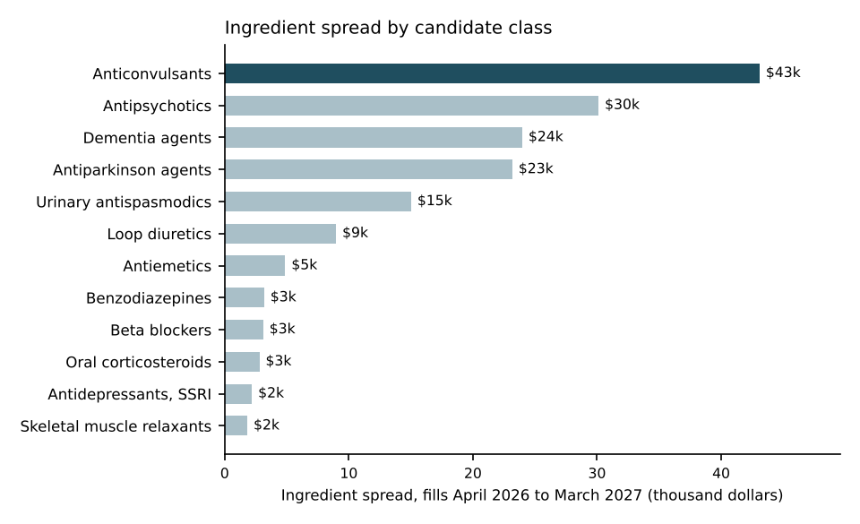
Figure 1. Ingredient spread by candidate class, fills April 2026 to March 2027, net of reversals; the proposed class in dark.
How the spread was measured
Claims are the Program's fee-for-service claims for fills from 1 April 2026 to 31 March 2027, reversals netted, each NDC placed in its class through the drug file and the class list in force from 1 January 2027. A claim's units are costed at the State AAC rate in effect for its NDC on the fill date. 43 per cent of the candidate classes' ingredient cost was paid on NDCs with no rate in effect, 86 per cent of it on unit-dose cartons and the rest mostly on new entrants' bottles; those units are costed at the median rate in effect that month for the priced NDCs of the same product and package. Where a product had no priced carton, its cartons are costed at its bottles' rate times the carton-to-bottle ratio of the products with both priced (about 1.90).
A carton costs more per unit than the bottle of the same product. Costed at the product's bottle rate, the cartons would carry a spread they do not have, and antipsychotics would appear first at $65,000.
The candidate classes' claims, units and ingredient cost paid for fills from April 2025 to March 2026 are in the attached workbook for the budget: the FY2026 utilization summary, which holds the payments made through 20 April 2026, with the later payments on those fills from this extract, classes as the current list defines them.

Carrie Arellano
MAC Pricing Lead

