NOTE TO THE PROVINCIAL CIVIL REGISTRATION COMMITTEE
From: Nicole Gomez, Research Associate, Population Studies Center Date: 14 November 2023 Re: CRIP 2024 first round
The City of Santa Cruz, San Isidro, Libertad, San Luis and Del Carmen register fewer than 80 per cent of their residents' adult deaths and go into the first round
Between the 2015 POPCEN and the 2020 CPH the five offices registered the deaths of about 52 to 64 per cent of their residents who died at 15 or over (indicator D1 in the terms of reference); every other office registered 89 per cent or more. The chart shows each city and municipality against the alert, with the range the estimate takes over the other usual ways of fitting it.
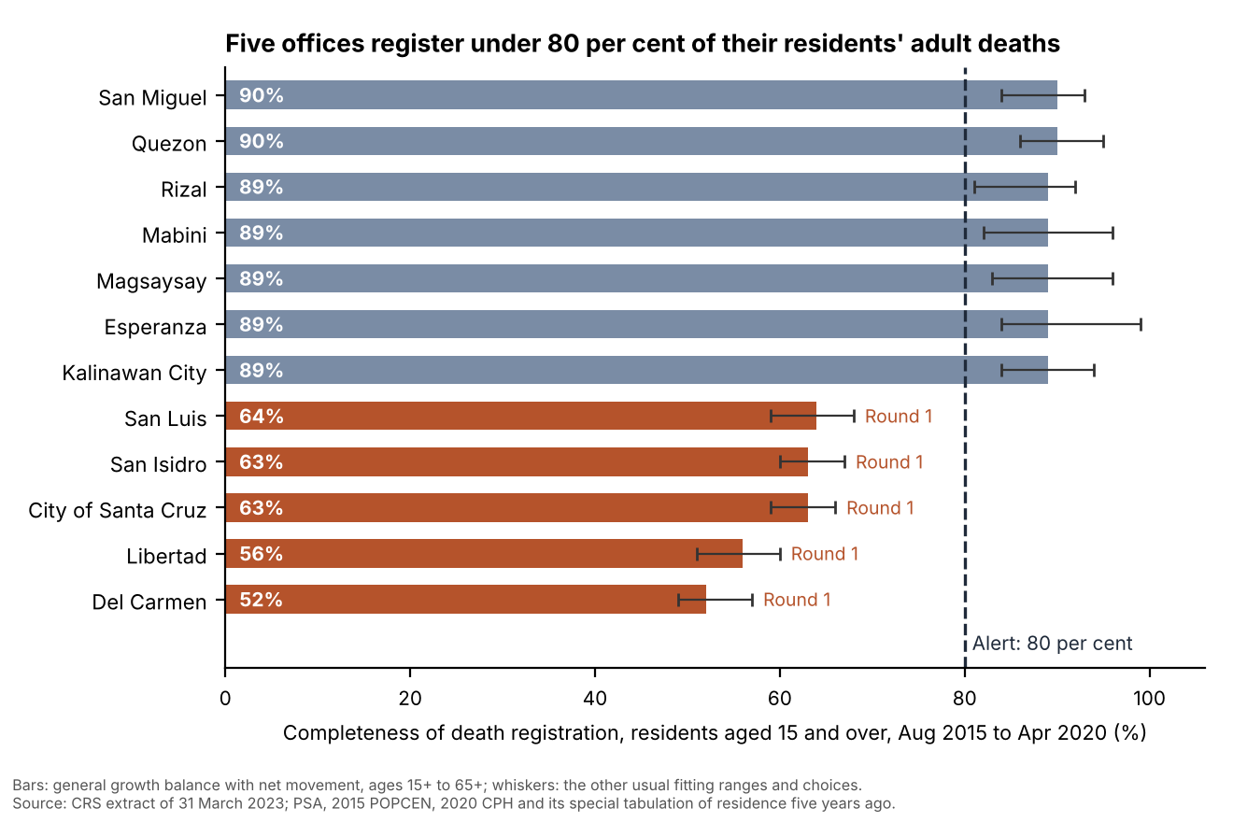
How completeness was read. There is no complete count of deaths to set the registered ones against, so D1 is estimated from the two censuses: between them the population above each age changes by the people who reach that age, the deaths above it and the people who move in or out above it, and the deaths the registers should hold follow from that balance (the general growth balance). Kalinawan's older residents move in numbers: in the five years to the 2020 census Esperanza lost a net of about 650 people aged 50 and over, Magsaysay about 540 and Mabini about 580, most of them to other parts of the country, while Kalinawan City gained about 370. Read as if nobody moved, the balance takes each departure for a death nobody registered and would put all three in the seventies, under the alert. With the movement from the 2020 census's question on residence five years ago in the balance, the residents who left the province included, the three farming municipalities register 89 per cent.
For the second round. Timely birth registration (B1) in 2022 ran from 61.0 per cent in Libertad to 88.0 per cent in Kalinawan City, counting each child once at its first registration. Medical certification of 2022 deaths (C1) ran from 37.8 per cent in San Luis to 84.6 per cent in the City of Santa Cruz: a certificate made in the health office's name counts only where the person who signed it held a physician's post that day, and in four offices the health officer's post was vacant for part of 2022. The workbook (lcro_death_registration_completeness_2015_2020.xlsx) has every figure.
Sources: CRS extract run by the PSA provincial office as of 31 March 2023; PSA, 2015 POPCEN and 2020 CPH household population; 2020 CPH special tabulation of residence five years ago (12 October 2023); PHO roster of the health offices' clinical staff (15 July 2023).

