MARROWFIELD UNIVERSITY HEALTH
Office of Research Integrity and Conflicts of Interest
To: Conflict of Interest Committee
From: Karen Shea, Director
Date: 27 January 2027
Subject: Docket for the meeting of 11 February 2027
Fifteen faculty members for the February docket
Under section 5 of Policy RI-14 the committee reviews the fifteen members of the clinical faculty with the largest remuneration from a single manufacturer in 2026. Open Payments will publish 2026 at the end of June, so the office has estimated each faculty member's remuneration from each manufacturer named in their 2026 annual disclosure: 279 faculty members holding an appointment on 31 December 2026 filed a 2026 disclosure naming a manufacturer, and all of them were estimated.
Section 5.4 has the office use the estimate that comes closest to the latest year Open Payments has published. Made from the 2025 disclosures and the years before them, and compared with what Open Payments' January 2027 publication shows for each of the 309 faculty members estimated for 2025, this one comes closer than any estimate that reads a disclosure as covering its whole year, and the variants of it that come closer still name the same fifteen. A disclosure carries what each company had paid by the day it was submitted, so a disclosure submitted in December misses the payments made after it. Each faculty member's reporting share is the total they disclosed over the total the register shows paid by the day each disclosure was submitted, on the manufacturer-years for which both a disclosure and a publication show remuneration, 2021 to 2025, weighted toward the same share across the whole faculty by n/(n+2), n the number of those manufacturer-years, the whole-number weighting that comes closest. Each 2026 amount is divided by that share and, where the disclosure was submitted in December, by the share of the year's payments the same manufacturer had made by that date the year before. A faculty member's estimate is the largest of their manufacturers'.
Five of the fifteen submitted their 2026 disclosure in the first days of December, before their retainers' December installments; corrected as if every disclosure covered the whole year, five of them would give way to faculty whose earlier December disclosures made them look like under-reporters. The record also carries faculty who disclose about half of what manufacturers report paying them, year after year, on records long enough to measure it; faculty whose records hold a single matched manufacturer-year are weighted toward the faculty-wide share rather than taken at their own.
The docket, in alphabetical order
Faculty member | Department | Manufacturer of the largest 2026 remuneration | Disclosed for 2026
Adam Andersen | Orthopaedic Surgery | Glenarde Joint Technologies, Inc. | $128,000
Kyle Avery | Hematology and Oncology | Norvell Therapeutics, Inc. | $92,000
Fernando Baldwin | Hematology and Oncology | Ambrell Biologics, Inc. | $41,000
Stacie Black * | Orthopaedic Surgery | Clevedon Surgical, Inc. | $54,000
Alexis Drake | Gastroenterology and Hepatology | Fallowfield Therapeutics, Inc. | $102,000
Henry Grimes | Neurology | Dunmere Neurotherapeutics, Inc. | $115,000
Pedro Hampton * | Gastroenterology and Hepatology | Morvanne Pharmaceuticals, Inc. | $53,000
Johnathan Kaiser | Cardiovascular Medicine | Pinewold Vascular, LLC | $48,000
Kerry Leach * | Cardiovascular Medicine | Kelsall Vascular, LLC | $54,000
Jillian Luna * | Dermatology | Varrick Pharmaceuticals, Inc. | $53,000
Kirsten Middleton | Cardiovascular Medicine | Tilbrook Heart Technologies, Inc. | $109,000
Vickie Nolan | Urology | Carrowmore Pharmaceuticals, Inc. | $51,000
Ruth Rosario | Neurology | Pallister Neurotherapeutics, Inc. | $41,000
Judith Valenzuela * | Hematology and Oncology | Yarrowby Oncology, Inc. | $53,000
Traci Ware | Orthopaedic Surgery | Saltmere Joint Technologies, Inc. | $51,000
Departments are those of each faculty member's primary appointment on 31 December 2026. The amount disclosed is from the 2026 disclosure in force on 21 January 2027, rounded to the nearest thousand dollars; an asterisk marks a disclosure submitted in December 2026.
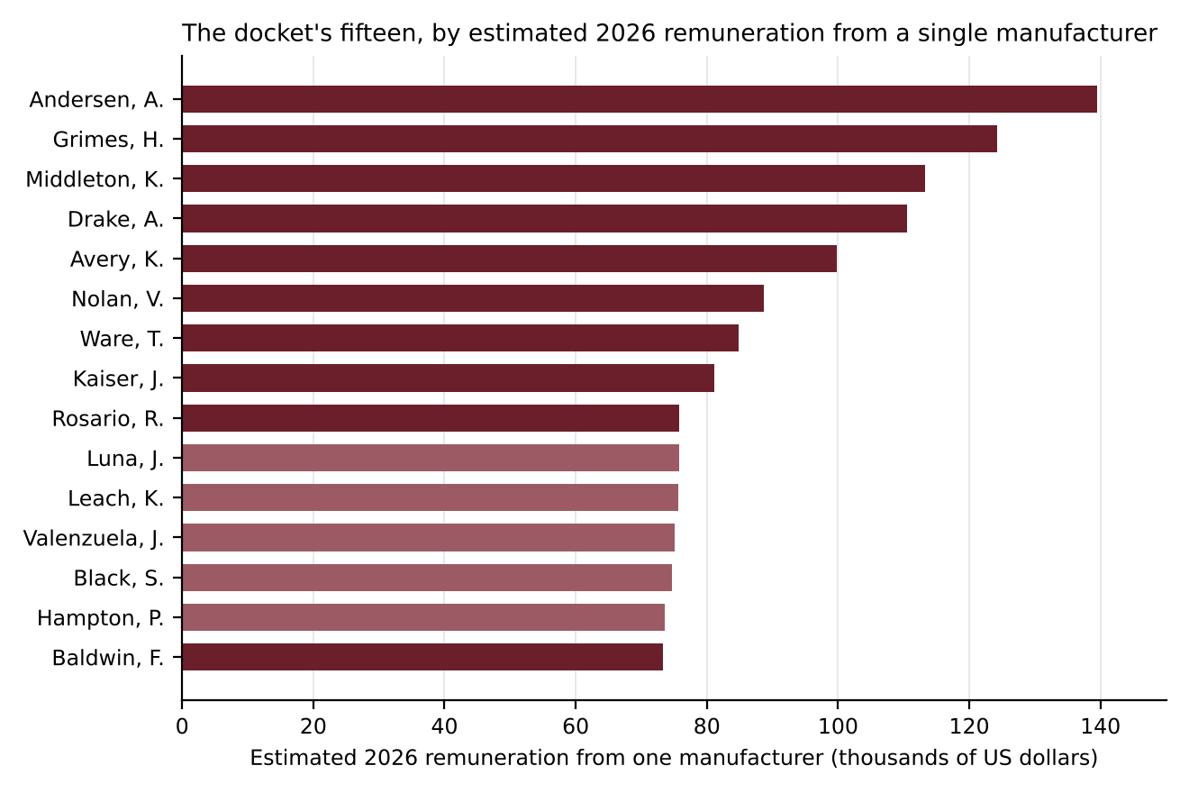
The lighter bars are the disclosures submitted in December 2026.
The 2026 disclosure cycle
1,696 faculty members owed a 2026 disclosure, and 91 of them had not submitted it by 11:59 p.m. Eastern time on 15 January 2027.
Owed: an appointment on 31 December 2026, each faculty member counted once; a faculty member whose employee number changed in 2026 filed under the number the disclosure system holds. Not submitted: no submission of the 2026 disclosure by the deadline; the disclosure system records times in UTC.
Open Payments, 2025: remuneration to the faculty
Nature of payment | Published for 2025
Consulting fees | $4,463,000
Services other than consulting, including speaking outside continuing education | $1,366,000
Honoraria | $819,000
Faculty or speaker, accredited or certified continuing education | $325,000
Faculty or speaker, unaccredited continuing education | $198,000
Open Payments' publication of 15 January 2027. Faculty members who held an appointment at any time in 2025, all of their 2025 records; records tied to faculty through Open Payments' covered-recipient profiles; payments made to the university at a faculty member's request excluded. Rounded to the nearest thousand dollars.
2026 remuneration from companies outside Open Payments
Relationship type | Disclosed for 2026
Consulting or advisory board | $56,000
Speaking or teaching | $11,000
Expert testimony | $97,000
Other paid services | $3,000
From the 2026 disclosures in force: companies that appear in Open Payments under no name, the names manufacturers reported under in earlier years included; two companies the entity list still shows without an identifier have reported to Open Payments since program year 2025. Rounded to the nearest thousand dollars.

