Fenwright Contact Services | Workforce Planning
35 dedicated analysts carry the Bellcroft desk's sustained workload into 2027
To: Bellcroft complaint steering committee, meeting of 15 October 2026
From: Catherine Schneider, Workforce Planning, Fenwright Contact Services
Date: 12 October 2026
Subject: dedicated team in the 2027 statement of work (for approval with the program budget)
Recommendation: carry 35 dedicated analysts in the 2027 statement of work (32 in 2026). Under WPS-3 the team is the sustained base, 950 new matters a week, over 27.5 matters per analyst-week, rounded up.
The base. The desk opened 11,597 new matters in the eight complete weeks before October (3 August to 27 September), 1,450 a week. About 500 a week of them arise from Meridel's May payment-posting failure as Schedule 7 defines a covered matter (one of the four codes, from a cardholder whose account had an affected payment); the rest, 950 a week, is the sustained base.
Counting the failure's matters. For matters with a confirmed account, 2,081 carry an affected payment. The social care desk's name-and-city matters cannot be checked one by one: their account is the first cardholder the name-and-city search returned, which is the poster's own only when the search returned one cardholder. Of those 597 matters, 478 (80 per cent) carry an affected payment, and the same share holds across all 2,395 name-and-city matters under the four codes when each attachment is weighted by its chance of being the poster's (the other cardholders carry the portfolio's 4 per cent). That puts about 1,920 of them on the failure, against 851 whose attached account happens to be on Meridel's list; counting only those would have sized the team at 40.
Open matters. The backlog peaked at the end of May and has come back toward its winter level; the counts below follow each matter's status history, so a matter closed and later reopened is not counted as open between the two.
Month end (2026) | Matters open
January | 720
February | 730
March | 710
April | 740
May | 8,260
June | 5,590
July | 3,230
August | 2,230
September | 1,850
Source: case system status history, extract of 9 October 2026. Counted at the close of each month's last day.
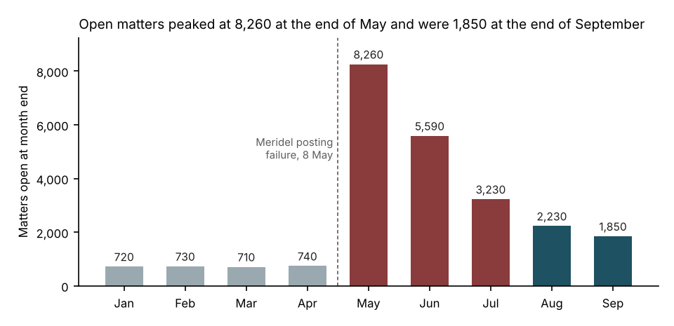
Flex line. Overtime and agency hours by month are in flex_hours_2026.csv; they peaked at 4,120 hours in June and were 2,170 hours in September.
Notes. Weeks run Monday to Sunday, Eastern time, and the eight are the last complete weeks before October, when the committee sets the budget (WPS-3 3.1). A matter merged into another as a duplicate, or reopened, is not a new matter (WPS-3 2.2). Covered matters are as Schedule 7 section 7.2 defines them, whether or not Bellcroft can claim them under section 7.4. Matters a week and open matters are rounded to the nearest 10 from unrounded counts; the team is rounded up from the unrounded base.

