Headline squad 2027: send the squad to Business·national
Owner: Corey Cox, Managing editor | Version 1, 19 October 2026 | Internal
Distribution: Lisa Jennings, Kayla Torres, Nina Franklin, Willie Smith; editors of the six shortlisted desks
Recommendation. The squad should join Business·national in January. It would add 500,000 article clicks to Bightline there in 2027. The runner-up is Local·metro, at 400,000, which sits 100,000 behind.

How the number is built
The brief judges the squad the way Experimentation closes an embedding: on the clicks readers make in its year that they would not have made without it. Three steps take a desk's 2027 clicks to that figure.
First, the lift. A desk's average winning lift over-reads what a winning headline is worth, because the variant that wins a small test is usually the one that drew a lucky sample. Each shipped variant is shrunk toward one prior fitted on every package in the test archive, and the desk's lift is the mean over its tests: 2.00% for Business·national. The same rule comes within 2% of the realised holdback lift for 7 of the squad's 7 finished embeddings; the raw lift does so for none.¹
Second, the clicks a shipped headline can reach. It replaces the old headline only on Bightline's own pages: the home pages, section fronts, app feed and tabs, and the related-story links. The squad also takes only the headlines a desk has not put under test itself. That leaves 34,900,000 of Business·national's 2027 clicks; at its lift, its winning headlines would win 700,000 clicks.
Third, how many of those clicks are new to Bightline. A page shows a fixed set of headlines. When a better headline wins a click from a reader who would have clicked something else on the page, Bightline has moved a click, not gained one. Only views that would otherwise end with no article click can give a new one, and the page analytics show how many those are. About four in five views of the Culture front and the Culture tab already end in a click (83% and 81%), against fewer than one in eight on the related-story links (12%). 52% of Business·national's reachable clicks come through related-story links, so 71% of what its headlines win is new. Culture·national's come mostly through its own front and tab, so only 27% of its are. The change log bears this out: planned clicks times the realised lift times each desk's new share comes within 2% of the extra clicks measured against the holdback for 7 of 7 embeddings. One average share for every desk is within 2% for 2 and misses by up to 57%.²
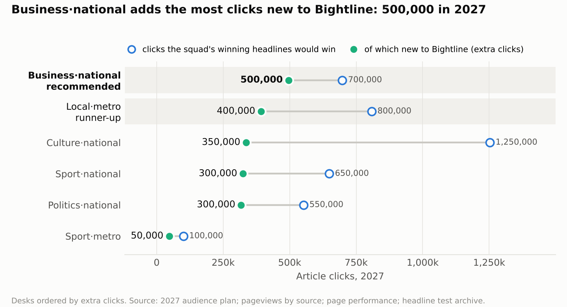
Chart: for each desk, the clicks its winning headlines would win and the share of them that is new to Bightline. Desks ordered by extra clicks.

Why not the other five
- Local·metro (400,000): the strongest lift on the list (2.57%), but its readers reach it through the Brisbane home page, where nearly half the views already end in a click, and its own front, where more than two thirds do, and its editors already test the headlines behind 71% of its own-page clicks.
- Culture·national (350,000): its winning headlines would win the most clicks of any desk (1,250,000), because its editors test very few of them. But 73% of those would be taken from the stories beside them on the Culture front and tab, so it adds 350,000 clicks to Bightline.
- Sport·national (300,000): a large audience, but a modest lift (1.32%) and half its own-page clicks already on headlines its editors test.
- Politics·national (300,000): leads on the dashboard's Politics figure (4.69%), but that average is pulled up by Politics·metro's small Brisbane tests; Politics·national's own tests shrink to 1.28%, and most of its clicks arrive through search, partner apps and social cards, which keep the stored headline.
- Sport·metro (50,000): the highest raw winning lift in the archive (10.8%), drawn from very small tests; shrunk, it is 0.39%.

Headline corrections
Politics·national has the most readers on the panel, but readers do not change how many new clicks a headline can bring. When one of Business·national's headlines is wrong, the first correction comes a median 89 minutes after the article goes live: 10 of its 37 corrected articles within the hour and 6 after more than three hours. The full set is below and in the workbook.³
Desk | Extra clicks 2027 | Median minutes to first headline correction | Within an hour | After more than three hours
Business·national | 500,000 | 89 | 10 | 6
Local·metro | 400,000 | 102 | 12 | 6
Culture·national | 350,000 | 119 | 1 | 5
Sport·national | 300,000 | 47 | 23 | 2
Politics·national | 300,000 | 86 | 14 | 7
Sport·metro | 50,000 | 55 | 9 | 2
Source: 2027 audience plan; pageviews by source; page performance; headline test archive; CMS revisions for the web desks. Corrections cover October 2025 to September 2026.

Notes
1 Prior fitted by maximum likelihood on all 10,111 variant packages; a control that is kept counts as zero lift. The workbook's Back-test sheet has both tests embedding by embedding.
2 Click-through is each page's article click-throughs over its views across the twelve months. A desk's clicks from the home page are on its edition's home page; from the front and the tab, on its own; the Pages sheet lists all 22 pages. The 2027 plan holds every desk at its October 2025 to September 2026 clicks.
3 A headline correction is a new note on a published version that went up with a corrected headline, the fix and the note on one save or on saves up to ten minutes apart, a live-blog entry's headline included (editorial standards 7.3 to 7.5); a note carried forward, or put back after a save that left it off, is not a new correction. Articles are stories and live blogs first published October 2025 to September 2026; live-blog entries and restored copies are not separate articles. An article goes live when it is first published, at its scheduled time (Brisbane) if the CMS published it then; a restored copy keeps its original's.

