MEMORANDUM
To: Jason Holland, Commissioner of Labor and Industry
From: Mackenzie Parks, Chief, Labor Market Information Bureau
Date: 23 October 2026
Re: Four workforce areas qualify for the 2027 portable benefits pilot (ARM 24.30.104)
Recommendation
Certify Northern Basin, Silver Creek, Upper River and Eastern Prairie as pilot areas for 2027. Capital Region, High Plains, Southwest Lakes and Timber Country do not qualify.
Across the state, 7 percent of employed residents held more than one job over the four quarters to September 2026, counted as residents report it themselves. The survey's published series, which takes every answer as given, shows 5.5 percent.
Basis of the estimates
When an adult is out at the time of the interview, the household member answering gives that adult's answers. Residents who were answered for in one quarter and answered for themselves in an adjacent quarter show that these answers carry only about 56 percent of the second jobs the residents report themselves. Second jobs are also more common among the residents who are out when we call, so the published series understates them, most in the areas where more adults are answered for. Each area's answered-for reports were corrected by that reporting rate; answers residents gave for themselves stand as given.
Workforce area | Employed with 2+ jobs (%) | Qualifies
Capital Region | 5.8 | No
Northern Basin | 7.8 | Yes
Silver Creek | 9.3 | Yes
High Plains | 4.4 | No
Upper River | 8.3 | Yes
Southwest Lakes | 5.6 | No
Eastern Prairie | 8.0 | Yes
Timber Country | 6.5 | No
Source: Tamarack Household Employment Survey, 2025Q4 to 2026Q3, final weights; LMIB calculations. Southwest Lakes' 2026Q3 weights are the 16 October reissue; the first issue leaves every area's qualification unchanged.
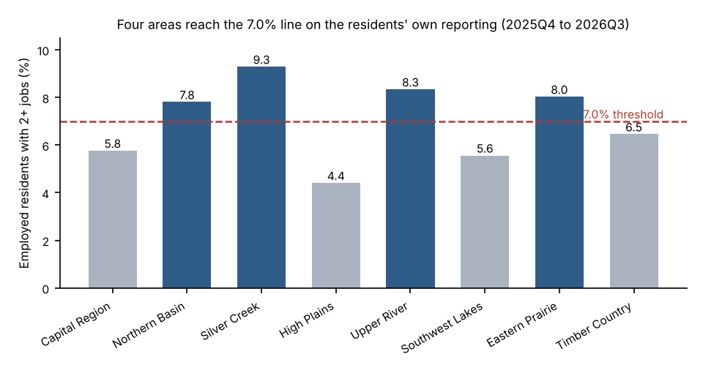
Survey quality
Household response rates over the same four quarters ran from 67.5 percent (Northern Basin) to 83.8 percent (Timber Country). Rates by area are in the workbook pba_pilot_areas_2027.xlsx, with noncontact rates; housing units found vacant or demolished at the visit are left out of the base.

