The 2027 demand response expansion should go to the Home Battery Network
To: Budget and Rates, for the Council's 2027 budget packet. From: Corey Cox, Resource Planning. 23 October 2026.
Recommendation: put the USD 3.2 million expansion line into the Home Battery Network. Its 2,133 added batteries count for 6 MW in the 2027 resource adequacy plan, more than any other programme the line could buy; Peak Time Rewards is next at 4 MW.
Why the batteries, when the thermostats look biggest on an average day
Chapter 4 of the plan counts a programme in the design year's system peak hour, 18:00 on Friday 23 July 2027. OP-7 calls every programme on each weekday with a forecast high of 110F or more (Independence Day and Labor Day excepted), and the design week clears that from Tuesday 20 July, so the peak hour is the fourth event day in a row. Our three summers of Ridgeway measurement show what that does: the thermostats, the rebate customers and the commercial sites each give less on every consecutive event day, and on the fourth day Cool Credit's reduction is about a fifth of a first day's. The batteries recharge from rooftop solar between events and hold their 3.0 kW setting whatever the run.
Programme | Units the USD 3.2M buys | MW in the 2027 peak hour
Home Battery Network | 2,133 batteries | 6
Peak Time Rewards | 50,000 customers | 4
Cool Credit | 12,307 premises | 3
Business Demand Partners | 133 sites | 2
Sources: Ridgeway Analytics measurement files, 2024 to 2026 seasons; Budget and Rates cost sheet, 2 October 2026; Resource Adequacy Plan 2027, chapter 4 and Appendix B.
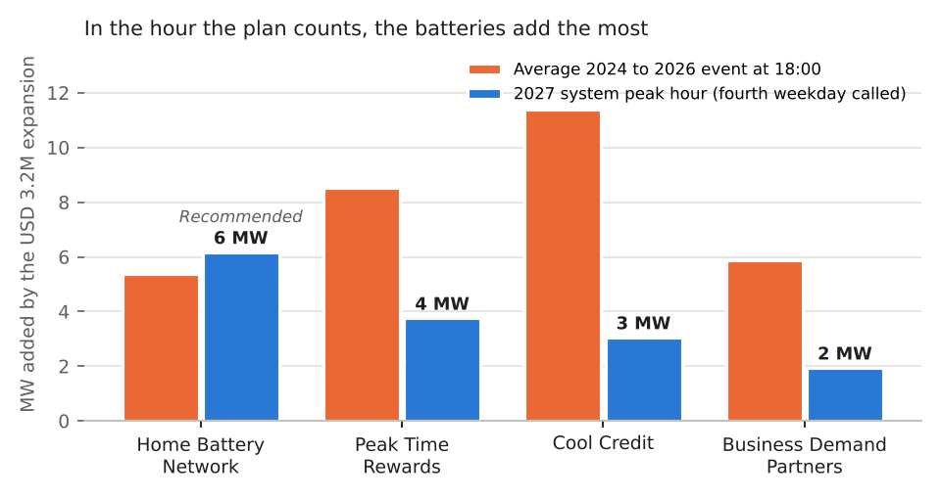
Each expansion's megawatts: grey on the record's average event, blue in the hour the plan counts.
The 2026 audit figures the Council asked for (thermostats online on each event day, battery incentives owed and Arroyo's nominations) are in dr_programme_audit_2026.csv.
Note: the batteries are read on their 2025 and 2026 events only, because Brightwell dispatched at 2.0 kW in 2024 and at 3.0 kW from the 2025 season (schedule 2, Amendment 1). Megawatts are rounded once, to the whole megawatt.

