History Paper 2, 2026: optional questions (code of practice, section 4)
Research and Standards, for the executive, 3 December 2026
Recommendation: raise every candidate's mark on Question 6 by 2 marks before the best two essays are credited and the Awarding Committee's boundaries are applied. Question 6 was 2.1 marks more demanding than Questions 4 and 5 taken together, over the code's line of 1.5; Questions 4 and 5 were not more demanding than the others (-0.7 and -1.4) and are not changed.
Section 4.2 asks what the paper's candidates would have earned on each question against the others. Candidates chose their two essays, and chose by the topics they knew: Question 6 was answered by about a third of the candidates, and those who took it knew its topic. Their marks on it, whether compared with the other questions' marks, adjusted for Section A, or set beside their own other essay, carry that knowledge and put Question 6 about half a mark harder. The 1,422 candidates who wrote all three essays chose nothing: every essay they wrote was marked, and the difference between each of their own three marks shows each question's demand with no choice in it. Their three essays were written in the time for two, which lowers all three marks alike and leaves the differences unchanged, and the candidates with low, middle and high Section A marks each put Question 6 over the line.
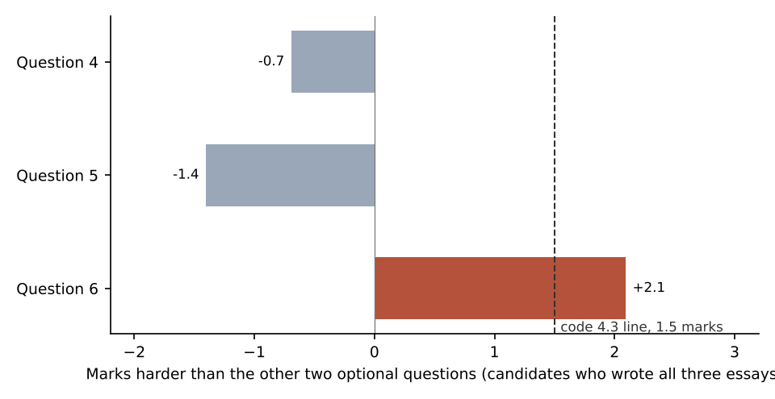
Grades after scaling (paper total, Section A and the two credited essays):
A | B | C | D | E | U | Graded
5,732 | 5,934 | 7,337 | 5,945 | 3,561 | 2,188 | 30,697
Scaling Question 6 changes 1,854 candidates' grades; no grade falls. The boundaries are those of the committee's minute of 24 November and are not moved (code 5.2).

