2027-2029 Sector Partnership Slate
To: Board of Directors, Tallis Valley Workforce Development Board
From: Beverly Ray, Labor Market Analyst
Date: 14 October 2026
Re: Industry slate for the 5 November 2026 vote
I recommend that the board name Information, Finance and insurance, Professional, scientific, and technical services and Construction as our slate for the State Sector Partnership Fund 2027-2029 round. They are the four of our 15 eligible industries whose pay per job grew fastest from 2021 to 2025. Manufacturing is next in line.
The Fund measures pay for the work done in each year, but the state's county file counts wages in the quarter they are paid. New Year's Day 2026 fell on a Thursday and was paid on 31 December 2025, which gave weekly Thursday payrolls 53 pay dates in 2025 and half of the every-other-Thursday payrolls 27. Nothing like that happened in 2021. I estimated how much of each industry's payroll runs on each weekly and every-other-week schedule from its quarterly wages since 2013 and took the extra pay date out of 2025.
It matters for two industries. Our hospitals and the large trucking and warehousing employers pay mostly on Thursdays, so on wages as paid Health care and social assistance shows 20% and Transportation and warehousing 20%, enough to push Professional, scientific, and technical services and Construction off the slate. For the work done both grew 17%.
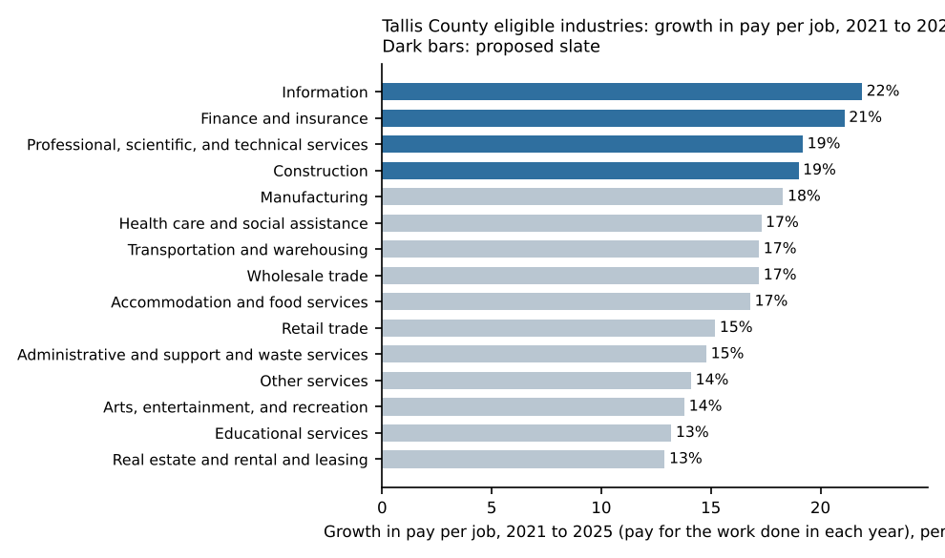
Application figures by industry (guidelines 3.2 and 3.3):
Industry (NAICS) | Pay per job growth | Slate | 2025 exiters employed, 2nd quarter after exit | 2025 ITA payments
Information (51) | 22% | Yes | 10 | $22,393
Finance and insurance (52) | 21% | Yes | 17 | $81,692
Professional, scientific, and technical services (54) | 19% | Yes | 27 | $47,625
Construction (23) | 19% | Yes | 38 | $69,436
Manufacturing (31-33) | 18% |  | 103 | $24,657
Health care and social assistance (62) | 17% |  | 167 | $99,153
Transportation and warehousing (48-49) | 17% |  | 53 | $63,586
Wholesale trade (42) | 17% |  | 33 | $50,013
Accommodation and food services (72) | 17% |  | 75 | $38,915
Retail trade (44-45) | 15% |  | 124 | $75,755
Administrative and support and waste services (56) | 15% |  | 54 | $36,332
Other services (81) | 14% |  | 29 | $63,259
Arts, entertainment, and recreation (71) | 14% |  | 13 | $70,984
Educational services (61) | 13% |  | 13 | $28,973
Real estate and rental and leasing (53) | 13% |  | 7 | $66,896
Exiters are counted once, at their last 2025 exit (a customer registered twice is one exiter), in the industry of the business that paid them most in the second quarter after exit; workers leased through a professional employer organization are counted in the client business's industry. ITA payments are the fiscal agent's 2025 checks net of voids, each check's installments assigned to the industry of the program they paid for.

