The new schedule takes the trucks' 2027 collision claims to 350
To: the board. From: Jenna Cole, Risk and Insurance Manager. Date: 2 November 2026. Subject: the number of collision claims for the 2027 motor claims fund.
I expect the delivery trucks to make 350 collision claims in 2027: 150 from April to September and 200 in the other six months, January to March and October to December.* The last three years averaged 280 a year on the current schedules.
The increase comes from the new schedule. From 2 January every route leaves between 03:45 and 05:15, so from October to March each truck starts its route in the dark, up to five hours before sunrise in midwinter. Over the last three years a kilometre driven before sunrise or after sunset carried about 2.6 times the collision rate of a daylight kilometre at the same time of day. Our early starts so far ran only on the May to August schedule, mostly after sunrise, which is why the small hours look like our safest driving if the history is read by time of day alone. The early starts that did begin before sunrise, on the May to August schedule, had 48 collisions against 37.6 expected on the darkness rate and 23.2 on the 04:00 to 07:00 rate.
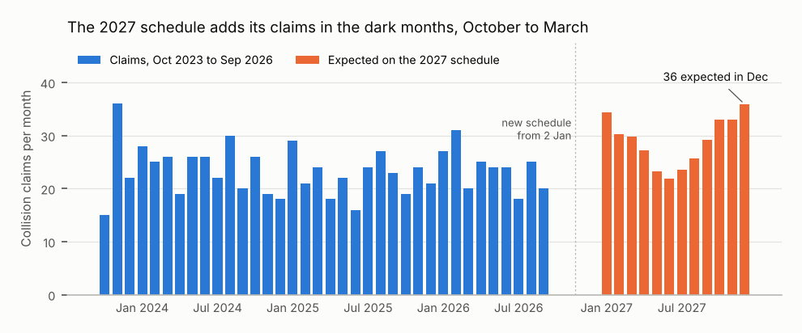
Source: Gridtrak day summaries October 2023 to September 2026; Ravensby claims listing as at 31 October 2026; 2027 route schedule and calendar; driver handbook Appendix C.
Other insurers have so far paid back £240,700 towards the 2025 collisions and £139,100 towards those of January to June 2026; the quarters are in the workbook. Brantwick's repair cost of each depot's collisions:
Depot | January to June 2025 | July to December 2025 | January to June 2026
Cramlington | £102,100 | £133,000 | £148,800
Gateshead (Team Valley) | £100,600 | £105,800 | £110,700
Carlisle | £91,700 | £127,400 | £92,500
Darlington | £89,600 | £67,700 | £114,800
* Claims as the fund terms count them: collisions of the delivery trucks, route trucks and spares, in the period of the incident date in UK clock time; company cars, duplicate notifications and withdrawn notifications are not claims. Money is net of VAT, to the nearest £100. Figures and workings are in claims_fund_2027.xlsx.

