2027 catchable tiers: lakes for the high-use tier
Stocking plan 2027, item for the November meeting. Prepared 26 October 2026.
Recommendation. Corriemore, Tessaly, Ellerdine, Kesterway, Quorrin, Brackwater, Pinewhistle, Ravensky, Inverkeld and Kittiwake go into the high-use tier for 2027; every other lake that takes catchables stays standard. Each of these lakes was fished for more than 500 angler-hours per hectare between 15 May and 31 August 2026.
How the hours were counted. The survey flights pass each lake at the same point in each loop, between about 09:30 and 12:00 in the morning and 14:30 and 17:00 in the afternoon, which is when anglers crowd the general-regulation lakes and when the fly-only lakes are at their quietest. The interviews give the time every party started and finished, so for each lake we know what share of its angler-hours fall in each hour of the 05:00 to 22:00 day. Each count was divided by that lake's share for the hour it was made, then averaged by survey day and raised to the season by weekday and weekend day in each month.
What this changes. Multiplying each count by the 17-hour day would have put Galloran, Nockell and Farrowdale in the tier and left Ellerdine, Quorrin, Ravensky and Inverkeld out: the fly-only lakes' anglers are on the water at dawn and in the evening, hours no flight sees, while the general lakes' anglers are out in the hours the flights cover.
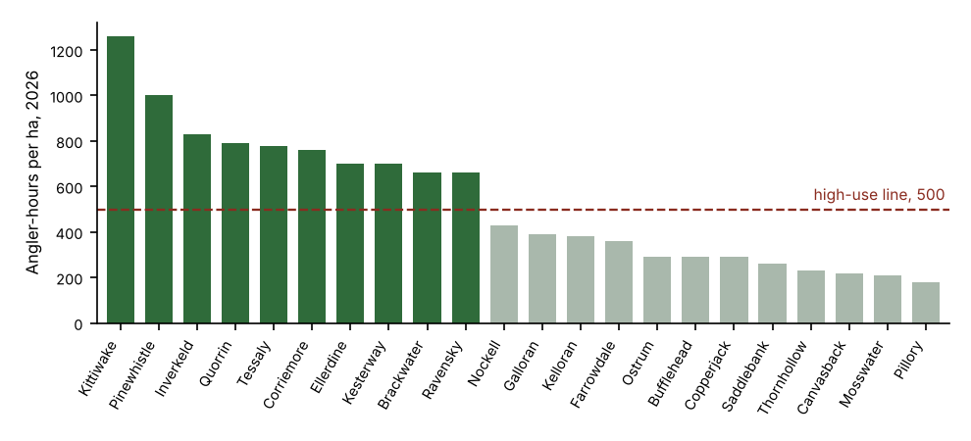
Angler-hours per hectare, 15 May to 31 August 2026; dark bars are the lakes recommended for the high-use tier.
Also in the workbook: the catchables each lake received alive in 2026 (64,700 in all, rounded lake by lake) and, for the lakes with a logger at 1 m, the July and August days the water there averaged above 20 C.

