Landesdienst für Geologie | Seismologischer Dienst
To | Bergbehörde Süd, Referat Geothermie
From | Seismologischer Dienst, induced seismicity (Gundula Atzler)
Date | 12 October 2026
Reference | LDG-SD-AO-2026-07
Subject | Traffic-light outlook for 2027 under the borehole networks

Pfeilbrunn will run over amber in the first and fourth quarters of 2027
On the networks that make the counts from 1 January 2027 we expect Pfeilbrunn to locate about 223 earthquakes of ML 1.0 or more within 5 km of its injection well in the first quarter and about 206 in the fourth, against the amber level of more than 120. Its second and third quarters stay under the line (about 70 and 44), so amber falls in the heating season. No other plant comes near amber in any quarter; the highest is Moorstetten at about 85 in the first quarter.
Pfeilbrunn has never been close to amber on its present network: 62 counted in the first quarter of 2026 and 77 in the fourth quarter of 2025. Those counts are what its town stations could record, not what the reservoir produces. The four stations stand in the town (school basement, waterworks, fire station, building yard), and through the working day traffic and works hide all but the larger earthquakes. From 23:30 to 05:00 they record every earthquake down to about ML 0.6, as the rural networks do at every hour. Over January 2023 to September 2026 they located 442 of the plant's earthquakes of ML 1.0 or more in those five and a half hours of the night, against 658 over the whole day. At the night rate round the clock the reservoir produces 28.0 such earthquakes per 100,000 m³ injected, 2.9 times the 9.6 its full-day record shows. The borehole stations, designed to locate every earthquake of ML 0.6 or more within 5 km, will count at that rate.
The usual completeness check does not show this. Pfeilbrunn's catalogue peaks near ML 0.4 like the others because the night fills the small magnitudes; what is missing is the day, and only the record by hour shows it.
Under section 4.2 of the scheme each amber notice obliges Stadtwerke Pfeilbrunn to cut injection by at least a quarter within 48 hours; its 2027 plan, filed on 1 September, sets every quarter at the 2026 volume and does not yet provide for that.
The rural networks at Moorstetten, Wendelsried and Ottenmoos record every earthquake above about ML 0.6 at any hour, and Lanzenried has done so since LZR5 replaced LZR4 nearer the well on 15 July 2025. Their 2027 counts follow their own rates; Lanzenried's higher counts since mid-2025 are that station move, not a change in the reservoir.
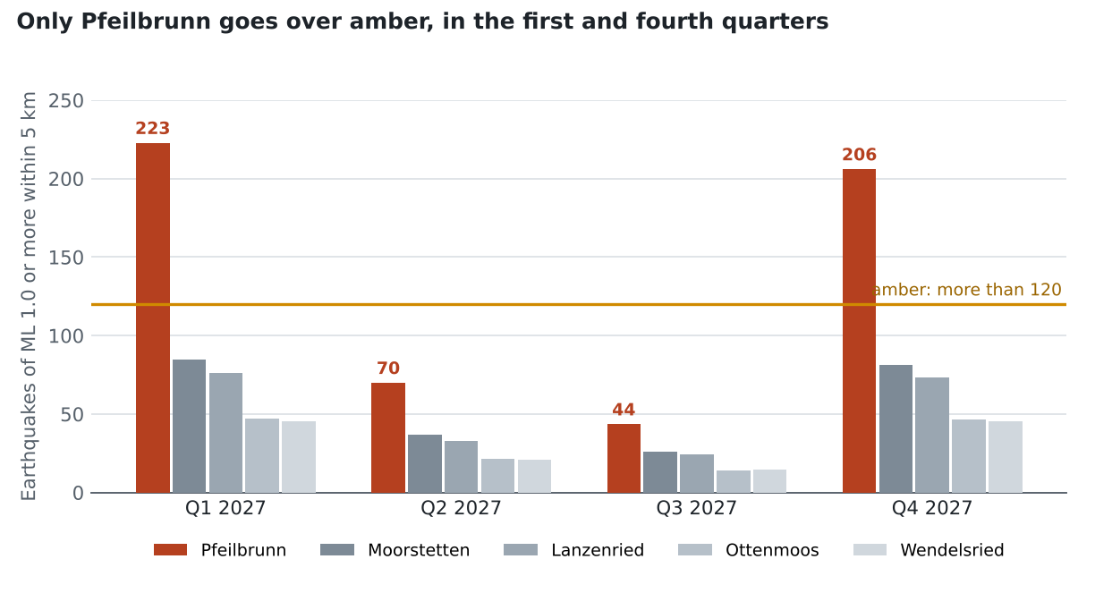
Figure 1. Expected earthquakes of ML 1.0 or more within 5 km of the injection wells, each quarter of 2027, against the amber level.
Expected count per quarter, 2027
Plant | Q1 | Q2 | Q3 | Q4
Pfeilbrunn | 223 | 70 | 44 | 206
Moorstetten | 85 | 37 | 26 | 81
Lanzenried | 76 | 33 | 24 | 73
Ottenmoos | 47 | 22 | 14 | 46
Wendelsried | 45 | 21 | 15 | 45
Each plant's rate per 100,000 m³ injected (the operators' reported volumes, each 2026 report counted for the month it reports) over its complete record, Pfeilbrunn's from 23:30 to 05:00 scaled to the day and Lanzenried's from August 2025, times the 2027 plan volume: each quarter as in 2026, the fourth as in 2025. Amber in bold. Another quiet-hour convention on the same record, such as Pfeilbrunn's night count against the volume injected in those hours or a window from midnight, moves a cell by up to 8 per cent; no method moves one across the line.
Counting as in section 3 of the 2024 scheme: epicentres within 5 km of the open hole of an injection well, ML of our reviewed catalogue, calendar quarters in local time. The 2026 measures for the annex to the operating plans are in the accompanying workbook.
G. Atzler
Head of induced seismicity

