Rotalinha Platform Reliability
To: Engineering leadership group From: Teresa Nogueira, Platform Reliability Date: 8 January 2027
Ref: PR-SLO-3 annual review 2026, latency objectives, read over December 2026 in Lisbon time
Five services ran over their latency budget in 2026
Five services ran over their 2026 latency error budget and get a reliability engineer for January to June 2027: journey-search, places, seat-map, partner-gateway and notifications.
Partner-gateway is the one a quick read misses: its SLI is 2.9% against a 2.0% budget, where the share of its spans the tracing store kept would put it at 0.8% and a reweighting of its own spans hour by hour at 1.4%. Journey-search, places and seat-map breach their 1.0% budgets at 1.3%, 1.5% and 1.5%, and notifications at 1.6%.
Service | Threshold (ms) | Latency SLI (%) | Error budget (%) | Ran over
journey-search | 1,300 | 1.3 | 1.0 | yes
fares | 300 | 0.6 | 1.0 | no
places | 150 | 1.5 | 1.0 | yes
seat-map | 500 | 1.5 | 1.0 | yes
booking | 3,000 | 0.4 | 0.5 | no
payments | 2,000 | 0.3 | 0.5 | no
tickets | 1,000 | 0.6 | 1.0 | no
accounts | 400 | 0.7 | 1.0 | no
partner-gateway | 1,000 | 2.9 | 2.0 | yes
notifications | 600 | 1.6 | 1.0 | yes
Source: trace_spans_2026-12.parquet and lb_target_group_requests_2026-H2.csv; thresholds and budgets from PR-SLO-3 section 4.
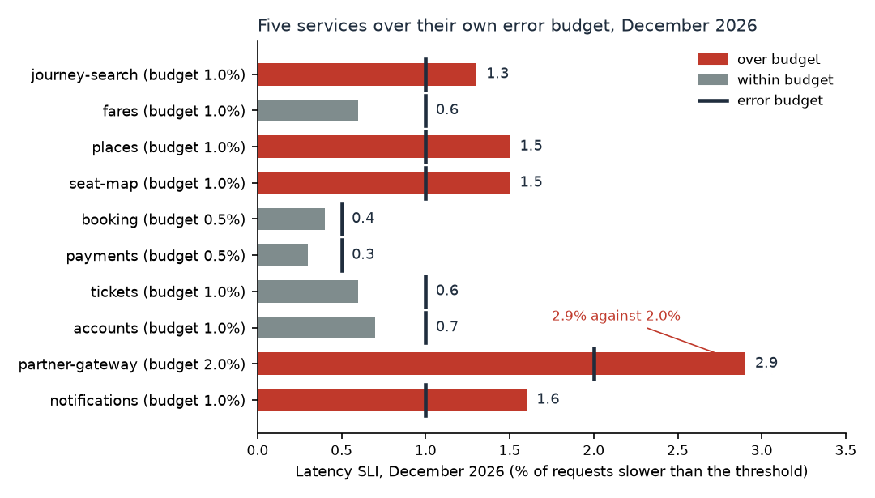
Each bar is the service's December SLI; the dark mark on it is the service's own error budget.
How the SLI was read
The tracing store keeps a trace whole or not at all, and the decision is taken where the trace starts: each edge service keeps about the same number of traces every hour whatever its traffic, so a busy hour is kept thinly. Each kept server span therefore counts for the requests its trace's edge service handled that hour over the traces it kept, from the load balancer's hourly counts; the SLI is the weighted slow spans over the service's December requests (PR-SLO-3 sections 2 and 3).
For an internal service the weight belongs to the edge request that started the trace, not to the service itself. Partner-gateway's kept spans come 33% from journey-search's traces, 33% from seat-map's and 34% from booking's, while journey-search's searches make 85% of its requests, and those availability lookups are the slow ones; weighting its spans by its own hourly keep share under-counts them.
Releases and rollbacks, customer-facing incident minutes and cloud cost by half are in service_sli_2026.csv, under PR-SLO-3 section 5.
Notes: SLIs are per cents to one decimal and are compared with the budget as rounded (PR-SLO-3 3.2). December in Lisbon time is UTC throughout. The load balancer's health probes are not requests (PR-SLO-3 2.2) and the trace export's re-sent spans are counted once.

