To: Jeff Guzman, VP Customer Onboarding
From: Revenue Analytics
Date: 23 October 2026
Re: Where the 2027 onboarding pod goes
Put the 2027 onboarding pod with the Southwest team
The Southwest is expected to add about 600 new paying customers in calendar 2027, more than any other region, and Texas & Gulf comes second. The pod should sit with the Southwest team for the year.
The Southwest does not lead on its own history. Fitted on each region's past new customers, trend, season and marketing plan, the forecast puts Texas & Gulf first and the Southwest second. What changes the order is where new customers come from: about two in five of our 2025 new customers were set up by someone who had used Plinthwise at a paying customer, left, and brought it to a contractor that was not yet one. The new company's first paid invoice comes a median of 10 to 11 months after they leave.
Between April and September 2026 the Southwest's paying customers removed about 6,500 users from their workspaces, about four times the region's 2025 monthly pace. Most were project managers, superintendents and engineers, and about half came from the region's largest contractors. At the rate past leavers have founded new customers, and counting each new company where it bills (close to nine in ten stay in the region they left), they account for about 400 of the Southwest's 2027 new customers, beside about 200 from its usual intake.
The forecast is on FP&A's FY2028 planning basis: marketing spend at Marketing Operations' plan, and users removed from paying customers' workspaces at each region's 2025 monthly average from October 2026. That is the cautious case for the Southwest: at the spring and summer pace its lead would widen, and with no removals at all after September it would still lead.
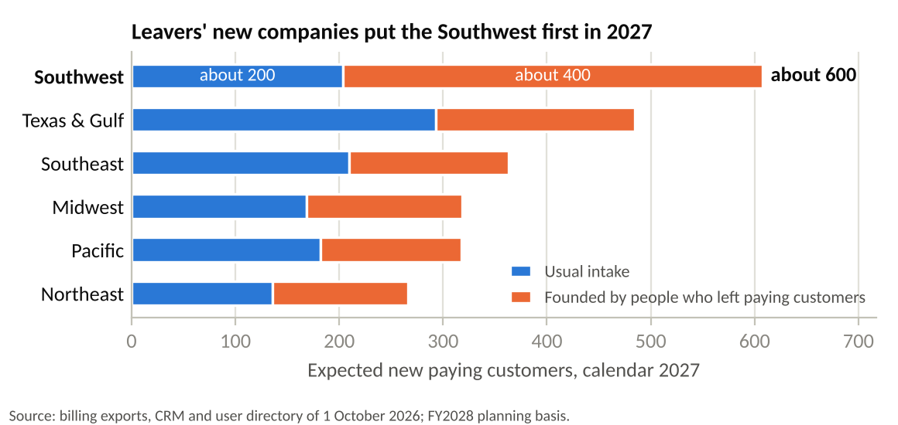
New paying customers as your memo of 20 October counts them: a first paid invoice, or a return more than 12 months after cancelling, dated in 2027, each company once at its parent, with voided invoices out; the region is the parent company's billing state on the March 2024 map. The 2027 figure is rounded to the nearest 200 and its parts to the nearest 100.
The pods' specialist hours and the 2025 customers by starting plan are in onboarding_staffing_2025.xlsx.

