2027 work plan: fix the SO-7 restoration switching revision
To the Board of Trustees, for the meeting of 24 November 2026. From Reliability Engineering, 3 November 2026.
Recommendation
Fund the 2027 fix for the SO-7 restoration switching revision. Since 1 December 2025 the control centre has re-energised each section in one switching step. Over the winter, sections restored that way after a long outage often tripped again on overload within minutes, interrupting the same members a second time. That cost about 8,700 sustained customer interruptions in fiscal 2026. The runner-up is the heat pumps connected without a load study at about 1,500, a gap of about 7,200.
What each change cost in fiscal 2026
Change (in place) | Sustained customer interruptions
SO-7 restoration switching revision (1 Dec 2025) | 8,700
Heat pumps connected without a load study (1 Nov 2025) | 1,500
Animal guard programme ended (1 Jan 2026) | 700
Riser termination replacements suspended (1 Oct 2025) | 700
Transformer supplier change (1 Feb 2026) | 100
Source: outage management system extract, fiscal 2022 to 2026, each change costed under Board Policy 407 section 3; to the nearest 100.
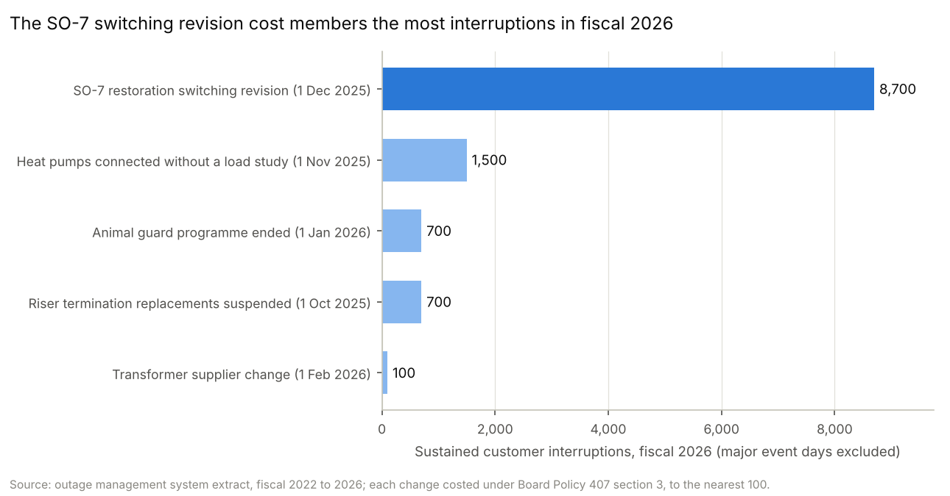
How each change was costed
Each change is costed under Board Policy 407 section 3: the customer interruptions in fiscal 2026 that would not have occurred without it, unplanned records of five minutes or more, major event days excluded (IEEE 1366, threshold 16.1 SAIDI minutes a day from fiscal 2021 to 2025).
SO-7 revision: every overload trip on a section that began within ten minutes of the same section's restoration from an interruption of an hour or more, from 1 December 2025. In the fourteen months of stepped pickup before it (October 2024 to November 2025) no restoration was followed by such a trip, so nothing is netted off.
Heat pump connections: overload interruptions on the service transformers serving members connected under the waiver, after each connection. A load study checks the service transformer and secondary, so these are the interruptions a study would have prevented; the rebate goes only to homes already heated electrically, and sections with a waiver connection re-tripped after restoration no more often than other electrically heated sections.
Riser terminations: failures at the risers on the 2025 replacement list from 1 October 2025. Animal guards: animal contacts at the 2026 list's sites from 1 January 2026. Transformer supplier: failures of Brekke units fitted from 1 February 2026.
The overload category as a whole rose by about 10,900 customer interruptions on fiscal 2025. Most of that rise is the re-trips above, not heat pump load.
Kayla Dean, Manager, Reliability Engineering
Note: fiscal 2026 had one major event day, 10 April 2026; its interruptions are excluded under policy section 3.2.

