Statistics Office | Section for Dwelling Statistics
Ministry of Local Government and Housing
Housing Policy Department
Attn. Eirik Haug
Our ref. 26/4470-3 Your ref. letter of 1 December 2026
12 January 2027
Certification under Section 7: vacant dwellings in the Hvitfjell pilot of the 2027 vacant dwelling activation grant
Five municipalities qualify for the grant: Tverrvika (7.3 per cent), Hesteby (6.4 per cent), Solmoen (6.5 per cent), Ørnevik (8.2 per cent) and Fjordeid (5.4 per cent). In each of them 5.0 per cent or more of the dwellings the regulation counts (Section 3) stood vacant in the reference fortnight of 9 to 22 November 2026 (Sections 4 and 6). The highest share below the threshold is Snøholt's 4.7 per cent. Across the county 396 of the 8,020 counted dwellings stood vacant.
Municipality | No. | Counted dwellings | Vacant dwellings | Vacancy share (%) | Qualifies
Brekkevoll | 5801 | 1,640 | 66 | 4.0 | No
Tverrvika | 5802 | 520 | 38 | 7.3 | Yes
Hesteby | 5803 | 980 | 63 | 6.4 | Yes
Kvernhaug | 5804 | 860 | 33 | 3.8 | No
Solmoen | 5805 | 430 | 28 | 6.5 | Yes
Ravnsund | 5806 | 740 | 34 | 4.6 | No
Ørnevik | 5807 | 380 | 31 | 8.2 | Yes
Langgrav | 5808 | 1,120 | 36 | 3.2 | No
Fjordeid | 5809 | 560 | 30 | 5.4 | Yes
Snøholt | 5810 | 790 | 37 | 4.7 | No
County |  | 8,020 | 396

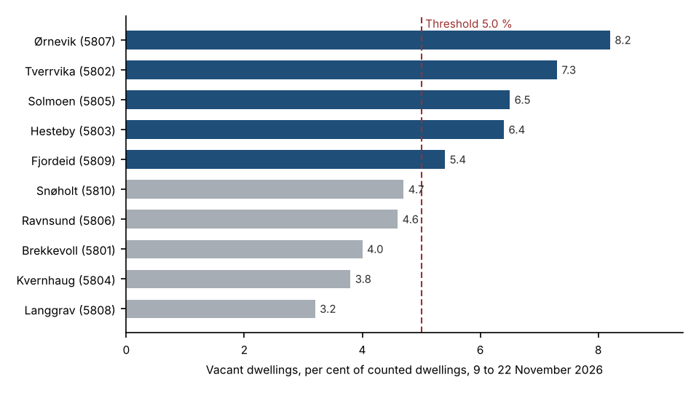
Figure 1. Vacancy share by municipality against the Section 6 threshold. Qualifying municipalities in blue.
How vacancy was established. Each counted dwelling was joined to its household metering points in the hub's extract, by the cadastre's unit ID or, for a house without one, by its address, and its hourly values were put on Norwegian time, the measured value kept where an hour had been estimated first, a dwelling's two points added where its meter was changed in the fortnight. A dwelling was taken as lived in when, on at least one day, its use in the morning or the evening rose above its own night-time use by more than 0.5 kWh an hour, the household's day; it was vacant when no day showed one. The level of use does not settle it in November: an empty dwelling here is left heated, and the vacant dwellings used a median 20.5 kWh a day against 19.5 for the lived-in ones. Nor does the register: 118 of the vacant dwellings still had someone registered in them on 1 November, and 557 lived-in dwellings had nobody registered.
The dwelling-level list is in county_dwelling_occupancy_2026-11.xlsx.
Table A. Persons registered as resident in the counted dwellings on 1 November 2026, by age that day
Municipality | No. | Under 18 | 18 to 66 | 67 and over
Brekkevoll | 5801 | 115 | 1,748 | 636
Tverrvika | 5802 | 86 | 670 | 227
Hesteby | 5803 | 106 | 1,122 | 425
Kvernhaug | 5804 | 80 | 907 | 281
Solmoen | 5805 | 72 | 516 | 215
Ravnsund | 5806 | 57 | 875 | 301
Ørnevik | 5807 | 86 | 462 | 189
Langgrav | 5808 | 141 | 1,342 | 503
Fjordeid | 5809 | 78 | 716 | 228
Snøholt | 5810 | 128 | 936 | 351
The register of 5 January 2027 with every event after 1 November undone. Where the cadastre renumbered a block's flats in November the register shows each resident moving to the new unit number on the day; those entries are a change of number, not a move.
Table B. Counted dwellings held on the land register on 1 November 2026 by the municipality or a company it owns
Municipality | No. | Dwellings
Brekkevoll | 5801 | 133
Tverrvika | 5802 | 17
Hesteby | 5803 | 149
Kvernhaug | 5804 | 80
Solmoen | 5805 | 27
Ravnsund | 5806 | 141
Ørnevik | 5807 | 23
Langgrav | 5808 | 136
Fjordeid | 5809 | 86
Snøholt | 5810 | 58
Titles as registered on 1 November 2026, transfers registered after that day undone. A company the municipality owns as defined in the ministry's letter, from the business register and the shareholder register; titles from before the business register in the municipality's own name are the municipality's.
Yours sincerely
Martine Strøm
Head of Section, Dwelling Statistics

