2025 tree outages: ash dying beyond the right-of-way, not the trimming
To: Lori Rodriguez, Manager of Right-of-Way and Vegetation Management
From: Reliability Engineering
Date: 14 October 2026
Subject: Review of the 2025 rise in tree-caused outages (ENG-REL-02 4.1) and the 2027 right-of-way budget increase

Fund hazard-tree removal beyond the right-of-way with the 2027 budget increase. Do not re-bid the trimming contract, and do not put the money into catch-up trimming.
The cooperative's tree-caused outage rate was 21.9 outages per 100 miles of overhead primary in 2025, against 11.2 on average over 2021 to 2023. North carries most of the rise: its rate went from 10.4 in 2023 to 20.5 in 2024 and 30.2 in 2025, after its trimming passed to Garrity Vegetation Services on 1 January 2024.
District | 2021 | 2022 | 2023 | 2024 | 2025
North | 11.6 | 11.2 | 10.4 | 20.5 | 30.2
East | 11.9 | 11.7 | 8.7 | 10.7 | 17.1
South | 11.8 | 12.0 | 11.4 | 12.4 | 14.2
Cooperative | 11.8 | 11.6 | 10.2 | 15.4 | 21.9
Tree-caused outages per 100 miles of overhead primary in service, outside major event days (ENG-REL-02 2.2). Source: outage management system export; trim-unit register.

Why it is not the contractor
The rise sits on North's units whatever crew trimmed them last. Set against North's 2025 rates at the same time since trim, the units Garrity last trimmed failed at 0.98 times the rate expected of them, and the units Hollenbeck last trimmed at 1.01 times. A crew leaving clearance short would show on its own units first; neither firm's units stand apart.

Why trimming sooner would not stop it
Read on the regrowth clock, North's 2025 rate rose by about 18.8 outages per 100 miles on units trimmed within the previous two years, where regrowth seldom reaches the line, about as much as on units near the end of their cycle. A tree falling in from beyond the right-of-way does that; regrowth inside it does not. The rise also climbs with the share of ash among the trees the forester's survey counts within falling distance of each unit: little on North's units with the least ash, most on those with the most, a gradient that was not there in 2021 to 2023 and appeared in 2024 with the rise. Ash dying beyond the right-of-way and falling onto the line does that.
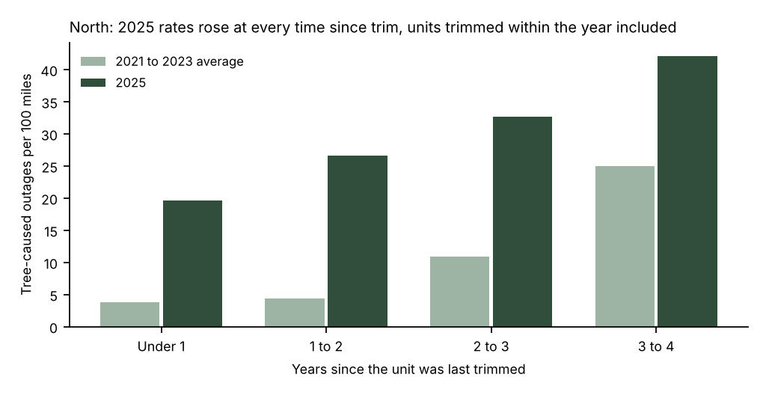
Time since trim runs from each unit's last accepted trim, or its in-service date where the line was rebuilt (OPS-ROW-01 3.1, 3.2). Source: outage management system export; trimming completions.

The other districts
East's 2025 rate (17.1) sits on units its April 2025 handover left past the four-year cycle, and South's (14.2) on a windier year; together they carry well under half of North's rise. Catch-up trimming in East answers its part; it is not where the cooperative's rise came from.
Rates exclude the major event days of 18 June and 9 December (IEEE Std 1366, 2.5 beta, from the five prior years). Workings are in tree_outage_workings_2025.xlsx.

