Pretrial diversion pilot cut convictions by 18 points: renew the agreement at the pilot's scale
To: Board of Commissioners
From: County Administrator's Office, Justice Planning
Date: 18 September 2026
Subject: Pretrial diversion pilot: report under Resolution 2025-31, sections 3 and 5

Requested action
Renew the agreement for 2027 at the pilot's scale. Being offered a place in the pilot's lotteries lowers the share of defendants convicted in the referred case by 18 percentage points, from 56% of defendants not offered a place to 38% of those offered one.¹ That clears the resolution's 15-point floor for renewal at the pilot's scale and falls short of the 25 points it sets for full scale.

What the pilot did to convictions
The two groups cannot yet be compared as the docket stands. On 31 August, 53% of defendants not offered a place had been convicted against 18% of those offered one, but most offered defendants' cases were still open, and for a reason that has nothing to do with whether they will end in conviction: a participant's case is continued for the twelve-month term, can only come back to court if the program terminates them, and then waits its turn on the trial calendar. The resolution counts every listed defendant by how the case ends, so each open case has been carried to its end on the rates the records show:
- Defendants not offered a place, and offered defendants who declined, are prosecuted in the ordinary way; an open case ends as the disposed cases of its group have, 56% convicted for those not offered and 55% for the 12% of offered defendants who declined.
- A participant still in the program fails in the months left on the term at the rate the program terminates participants month by month, counted over every participant's months on the program. Most terminations come early, and the review at the end of the term terminates 23% of the participants who reach it; only participants from the June, July and August 2025 draws have reached it so far. The chance of termination within the term is 39%.
- A terminated case is tried on the stipulated record the agreement carries: 91% of terminated cases already disposed ended in conviction, against 56% for defendants never offered diversion.
On those rates 38% of offered defendants will be convicted against 56% of those not offered, a reduction of 18 percentage points. The chart shows why the recorded shares overstate the pilot's effect: the offered group's recorded share is still rising when the records stop, and the participants terminated at the final review will not be tried until after the evaluation date.
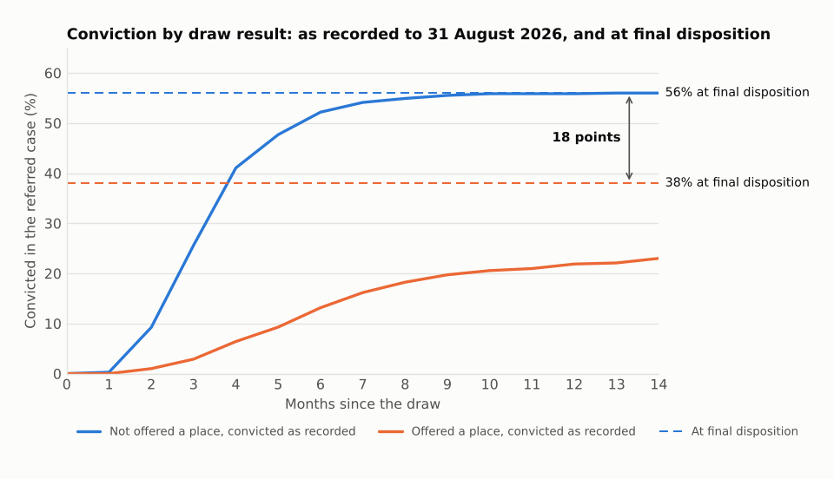
Source: Pretrial Diversion Unit lottery lists, June 2025 to May 2026; District Court docket, legacy and new case management systems, events to 31 August 2026. Recorded shares are cumulative by month since each defendant's draw.

Sizing full scale: eligible filings in fiscal 2026
A full-scale program would offer a place to every eligible defendant. As a first measure of that pool, the table counts the cases filed in fiscal 2026 whose lead charge falls in one of the program's eligible offense classes, before the Unit's screen for prior record and other exclusions.²
Eligible class (PDU-2026-01) | Cases filed
Theft and fraud | 1,962
Criminal damage | 655
Drug possession | 1,219
Public order | 1,125
License and driving | 947
All eligible classes | 5,908
Source: District Court charge records, legacy and new systems; penal code conversion table 2026. Each charge is read in the section numbering it was entered under.
Court division | Eligible cases filed
Larkmoor City | 2,325
Bramwick | 1,445
Wendmoor | 1,219
Strandham | 919
Source: as above, by the division in which the case was filed.

Program delivery under the agreement
Community service hours participants worked and restitution they paid in fiscal 2026, by the Nethercote site that supervised them.
Site | Community service hours | Restitution paid ($)
Larkmoor City | 8,051 | 37,165
Bramwick | 5,194 | 33,175
Wendmoor | 4,926 | 25,530
Strandham | 3,339 | 19,325
Source: Nethercote monthly participant reports, July 2025 to June 2026, from both of its case systems. Restitution is what participants paid; Nethercote remits it to the Clerk less the five percent the agreement lets it retain (clause 6).
Notes
1. Shares count every defendant on the monthly lottery lists, whether or not the case had ended by 31 August 2026 (Resolution 2025-31, section 3). Shares are rounded to whole percents and the reduction is taken before rounding.
2. Fiscal 2026 runs from 1 July 2025 to 30 June 2026 (Resolution 2025-31, section 6).
Savannah Jordan, Criminal Justice Planner

