To: Calvin Garrett, CFO
From: Revenue Planning, FP&A
Date: 16 October 2026
Re: First-time-employer line, 2027 operating plan
2,500 first-time employers for 2027 in the twelve core states
We put 2,500 new first-time employers in the 2027 plan's first-time-employer line. Ohio, Pennsylvania and Michigan now file the IRS employer number application from inside their online formation filings and have closed their older filing routes, so about 300,000 of their 0.9 million applications in the twelve months to September 2026 are ones the integrated filing added. Read against the nine other states before and after go-live, the added applications in the closed cohorts formed employers, taking the three states together, at under a third of the rate of the applications those states would have had anyway, and they are about a third of the three states' applications in the twelve months against about a fifth of the closed cohorts'. Every state's ordinary applications also rose about a tenth into the twelve months, from early 2026. Priced that way, the twelve months' applications will produce about 105,000 employer formations within four quarters, and at the 2025 shares that is 2,500 first-time employers, about four fifths of them in the three states.
The 2024 cohort is the nearest guide to what the line is worth: 2,190 first-time employers signed across the six territories, 1,761 of them still with us in the fourth quarter of 2025. The workbook has each territory's first-quarter and 2024 wages and the channels the cohort came through.
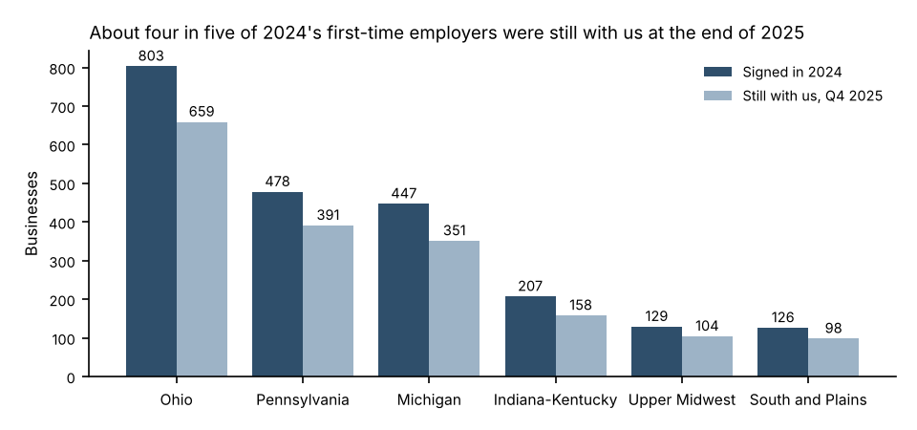
Source: year-end planning extract of 9 January 2026, counted as in Sales Operations' counting notes of 3 February 2026 (a business once, in the territory of the state it first employed in).
Shares are Sales Operations' 2025 shares in the plan workbook, refreshed from the BFS October 2026 release on 15 October; the line is the twelve states' sum, rounded to the nearest 100 as the 2027 sizing standard asks.

