Executive Risk Meeting, 18 November 2026. Paper ERM-26-41. For decision.

Transaction monitoring: the 2027 tuning set
From: Katherine Cobb, BSA/AML Officer. Prepared with Financial Crimes Analytics (Miguel Swanson) on the monitoring tables and the case manager export of 2 November 2026.

1. Decision sought
The meeting is asked to approve CRY-OFF, CSH-VEL, DRM-REA and PRF-DEV as the scenarios going into the 2027 tuning, and no other scenario, so the tuning plan can be in place before the independent AML review opens on 11 January.

2. The standard
As agreed in March, a scenario goes into the year's tuning when fewer than 3 per cent of the alerts it raised in the twelve months to 30 September end in a SAR. Every alert raised in those months counts, those still under investigation on 2 November by how they will end; the copies raised by the 11 March re-run are not counted, and XB-HRJ is read with XB-HRJ2, which replaced it on 1 April.

3. Each scenario against the floor
Scenario | Alerts raised | Ended in a SAR so far | Undecided on 2 November | Productivity, % | 2027 tuning
PRF-DEV | 10,960 | 128 | 75 | 1.5 | Yes
DRM-REA | 3,104 | 47 | 19 | 1.9 | Yes
CSH-VEL | 7,254 | 132 | 46 | 2.2 | Yes
CRY-OFF | 2,681 | 46 | 30 | 2.2 | Yes
MUL-INF | 4,911 | 113 | 127 | 4.5 | No
RMF-P2P | 3,884 | 103 | 91 | 4.5 | No
MER-RND | 3,258 | 87 | 82 | 4.6 | No
XB-HRJ / XB-HRJ2 | 2,841 | 112 | 43 | 4.7 | No
ATM-WDL | 2,263 | 101 | 38 | 5.4 | No
CHB-ABU | 1,495 | 90 | 25 | 6.6 | No
FAN-OUT | 3,633 | 165 | 107 | 6.6 | No
GMB-SPL | 1,083 | 56 | 36 | 7.2 | No
ELD-EXP | 1,661 | 106 | 34 | 7.7 | No
CSH-LDS | 6,210 | 489 | 74 | 8.6 | No

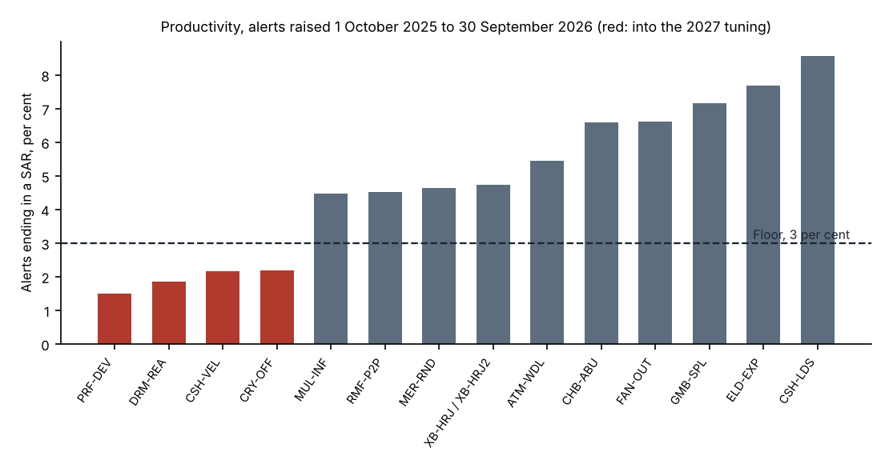

4. The scenarios close to the floor on the decided alerts
RMF-P2P, MUL-INF and MER-RND are not in the set, although the SARs they have produced so far are under 3 per cent of their decided alerts. Their investigations run the longest of any scenario: on 2 November 91, 127 and 82 of their alerts from the year were still under investigation, and of their alerts from before the year that were still undecided two months after the alert, most went on to a SAR. Read with the open alerts by how they will end, each is above the floor.

5. How the figures were read
Each alert is dated by the business date of its run. An alert ends in a SAR when the investigation it was escalated into, or added to, files one. An alert still undecided on 2 November is counted at the share of the scenario's alerts raised at least 330 days earlier, undecided at the same age, that went on to end in a SAR.

6. Next steps
On approval, Financial Crimes Analytics will draw up the threshold work for each scenario in the set with the scenario owners and bring the tuning plan to the Model governance forum in December.

