BOARD PAPER | ITEM 6 | FOR DECISION
The 2027 round of the Regional Visitor Infrastructure Fund: Jabiru Coast, Lyrebird Peninsula, Spinifex Gorges, Tingle Ranges and Yallambee Valley
Meeting of 18 February 2027. Prepared by Samantha Mooney, Manager, Visitor Economy Research, with Tina Garza, Fund Manager, 5 February 2027.

Recommendation
That the board fund Jabiru Coast, Lyrebird Peninsula, Spinifex Gorges, Tingle Ranges and Yallambee Valley in the 2027 round, each region receiving $1,771,508.

The ranking
Section 4 of the round's guidelines funds the five eligible regions with the highest visitor spending per resident in 2026. Pelican Coast is the first region below the line at $3,205 per resident, $945 short of Yallambee Valley at $4,150 (Table 1, Figure 1).
Gidgee Basin and Carisbrook Tablelands rank seventh and eighth although both take a great deal of card spending on cards whose statements go to other regions. Those cards belong to the basin's rostered mine workforce and, in Carisbrook, to university students, people who travel in from Mulga Plains for work and households that moved there with their card statements still going to their old address. They are in the region month after month, so the region is part of their holders' usual environment and what they spend there is not visitor spending.
Table 1. Eligible regions ranked on visitor spending per resident, 2026
Region | Visitor spending 2026 | Per resident
Jabiru Coast | $520,878,000 | $10,149 | Funded
Lyrebird Peninsula | $403,034,000 | $5,894 | Funded
Spinifex Gorges | $51,198,000 | $5,197 | Funded
Tingle Ranges | $103,866,000 | $4,272 | Funded
Yallambee Valley | $127,746,000 | $4,150 | Funded
Pelican Coast | $234,079,000 | $3,205
Gidgee Basin | $57,460,000 | $2,657
Carisbrook Tablelands | $115,532,000 | $2,547
Lower Wollomby | $58,966,000 | $1,521
Mulga Plains | $38,801,000 | $1,387
Port Kelburn | $72,231,000 | $1,167
Visitor spending is rounded to the nearest $1,000 and per-resident figures to the nearest dollar, each from unrounded spending. Residents: preliminary estimated resident population at 30 June 2026, shared areas at their Schedule 1 share.
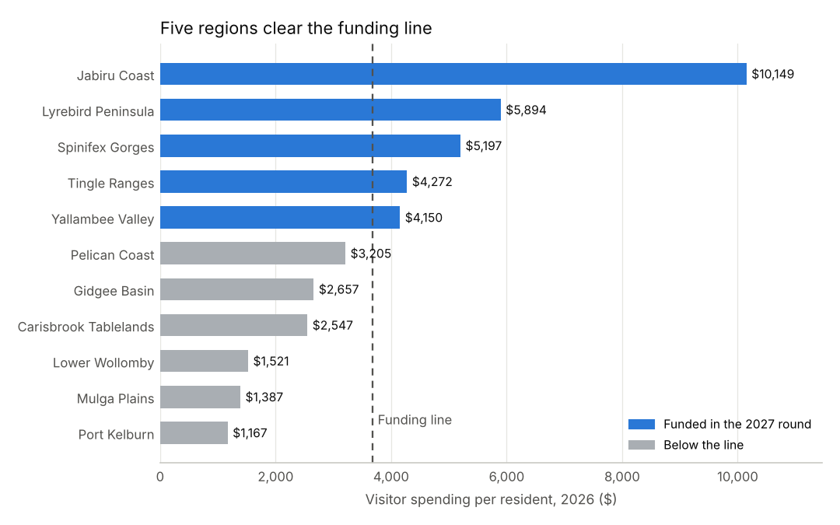
Figure 1. Visitor spending per resident, 2026, every eligible region. Source: Austral Payments Network research sample for 2026, raised by selection weight.

What each funded region receives
The round starts from the 2027 appropriation of $12,000,000. The board's decision of 21 October 2026 closing the Regional Tourism Infrastructure Program adds the $709,970 of unspent grant money councils returned to the program in 2026 and takes out the $3,852,430 that remained at 31 December 2026 on the program's open agreements, which the Fund now pays (Table 2). The round's total is $8,857,540, shared equally among the five regions, so each receives $1,771,508.
Table 2. The closing program by region
Region | Remaining on open agreements at 31 December 2026 | Unspent money returned in 2026
Jabiru Coast | $506,601 | $76,015
Lyrebird Peninsula | $170,544 | $151,408
Yallambee Valley | $430,427 | $34,369
Spinifex Gorges | $242,639 | $35,438
Tingle Ranges | $78,062 | $120,613
Pelican Coast | $586,137 | $49,918
Gidgee Basin | $136,751 | $23,772
Carisbrook Tablelands | $507,843 | $65,920
Lower Wollomby | $315,531 | $78,703
Mulga Plains | $593,995 | $48,060
Port Kelburn | $283,900 | $25,754
All regions | $3,852,430 | $709,970
Source: grants management system, agreements at 31 December 2026 and 2026 claims; accounts payable and receivable, 2026. Finance pays each council's approved claims in one weekly transfer quoting the agreement of the first claim, so each transfer is booked to the claims it paid. Claims approved in the last days of December, and a few approved earlier, had not been paid by 31 December 2026 and remain on their agreements. The 20 March 2026 payments repeated the 19 March run. Money a council sent back for them is not unspent grant money, and some councils had not sent theirs back by 31 December 2026.

Basis of the visitor figures
A card's spending in a region counts as a visitor's only where the region lies outside its holder's usual environment as the International Recommendations for Tourism Statistics 2008 define it. The usual environment is read from the card's own year in the sample: a region it is in month after month on many days is where its holder lives, works or studies, whatever address its statements go to, and a region it is in for a few days in one to three months is a trip.

