Coraza Independent School District | Office of Assessment and Accountability
Fifteen campuses fall under the 40 per cent line on the spring 2026 grade-5 results
To: Christopher Murphy, Superintendent of Schools, and the superintendent's cabinet
From: Susan Bird, Executive Director, Assessment and Accountability
Date: 12 October 2026
Subject: campuses designated for 2027 mathematics intervention coaching (District Improvement Plan, 2027 amendment)
Place the 2027 mathematics intervention coaches at the 15 campuses below. Each is a rated elementary campus where fewer than 40 per cent of its tested full-academic-year grade-5 students met the standard on the spring 2026 District Mathematics Assessment (designation rules 2 to 7). Across the 54 rated campuses, 47.9 per cent met it.
Campus | Learning community | Tested | Met the standard | Share (%)
Wolfberry Trail Elementary | South | 132 | 17 | 12.9
Javelina Run Elementary | South | 55 | 9 | 16.4
Arriaga Elementary | East | 132 | 33 | 25.0
Sotol Mesa Elementary | West | 65 | 18 | 27.7
Rosedale Terrace Elementary | Central | 114 | 32 | 28.1
Gallardo Elementary | East | 137 | 41 | 29.9
Caliche Ridge Elementary | West | 66 | 22 | 33.3
Old Mill Road Elementary | East | 143 | 48 | 33.6
Agarita Bend Elementary | West | 116 | 39 | 33.6
Ursuline Avenue Elementary | Central | 67 | 23 | 34.3
Lechuguilla Gap Elementary | South | 64 | 22 | 34.4
Tobar Elementary | South | 176 | 61 | 34.7
Guayacan Hill Elementary | North | 103 | 37 | 35.9
Mabry Elementary | Central | 140 | 51 | 36.4
Vance Avenue Elementary | Central | 117 | 43 | 36.8
Source: spring 2026 responses (platform export of 9 October 2026) scored with the corrected key; student information system enrollment for 2025-26. Tested and met are full-academic-year students.
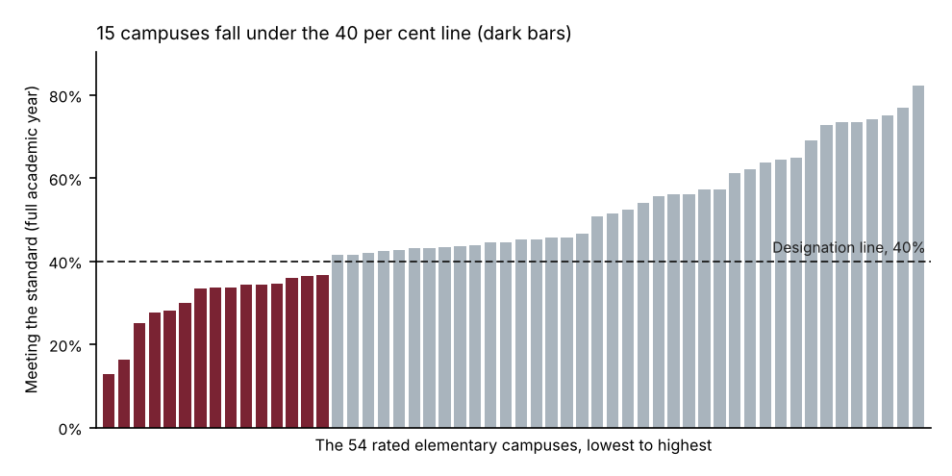
Placing 2026 scores on the scale. The 2026 grade-5 form keeps 25 of the 2025 form's items in the same positions and replaces the other 25 with new ones, so the 2025 conversion (141 + 6 x raw score) belongs to the 2025 form only. On the 22 shared items the 2026 students averaged 11.08 points against the 2025 students' 10.69: this cohort is stronger, while its average raw score on the whole form fell from 24.97 to 24.07, so the new items are harder by more than the cohort gained. Linked to the 2025 scale through those shared items, a 2026 raw score of 25 converts to 300 or more and 24 to less, so 25 is the passing raw score on the 2026 form.
Which shared items carry the link. Before linking, each shared item's difficulty was compared across the two years. Items 3, 11 and 35, all written to TEKS 5.4F (simplifying numerical expressions), moved far more than the rest: the 2026 students answered them correctly 79.1, 75.1 and 77.4 per cent of the time against 51.3, 45.8 and 47.4 per cent in 2025, while the other 22 rose from 48.6 to 50.4 per cent on average. The new curriculum reaches that standard a year earlier, so those three items no longer measure the same thing in both years, and the link runs through the other 22. Every standard screen flags the same three (the change in Rasch difficulty, Mantel-Haenszel, the delta plot).
Why not the published conversion. Read through the 2025 conversion, the passing raw score stays at 27 and 32 campuses fall under the line; matching the 2026 score distribution to 2025's, which assumes the two cohorts are alike, puts it at 26 and designates 23. The shared items show the cohorts are not alike: the 2025 conversion counts the new items' difficulty against every student, and matching the distributions reads this cohort's gain as an easier form. Linked through all 25 shared items, the three items' rise is credited to the whole cohort: the passing raw score falls to 24 or below, depending on the method, and 13 or fewer campuses are designated.
Notes. Item M547961 was scored with key B, as the notice of 19 May 2026 corrects the bank's C. Delgadillo Elementary's students are counted with Tobar Elementary, which takes in its zone for 2026-27 (rule 5). Vereda Elementary, opened in August 2025, had fewer than ten full-academic-year students tested and is not rated (rule 6). Shares are rounded to one decimal; designation compares the unrounded share with 40 per cent. Every rated campus's figures are in grade5_math_results_2026.xlsx.

