PLANNING NOTE: VERIFICATION DESK, MAY TO SEPTEMBER 2028
To: the surveillance manager From: Fiona Chandler, wastewater surveillance coordinator Date: 13 April 2028
Plan the desk for 26 alert episodes this winter, not the 30 the dashboard published for last winter.
Read on the shed load, last winter's samples (May to September 2027) raise 26 alert episodes against the 30 the dashboard published. Ardenmouth South WWTP (ADS), Ardenmouth East WWTP (ADE), Tarnbrook WWTP (TRN), Cleaveland Flat WWTP (CLF) and Saltmarsh Point WWTP (SLT) each lose an episode and Ardenmouth West WWTP (ADW) gains one; the other eighteen plants keep their counts.
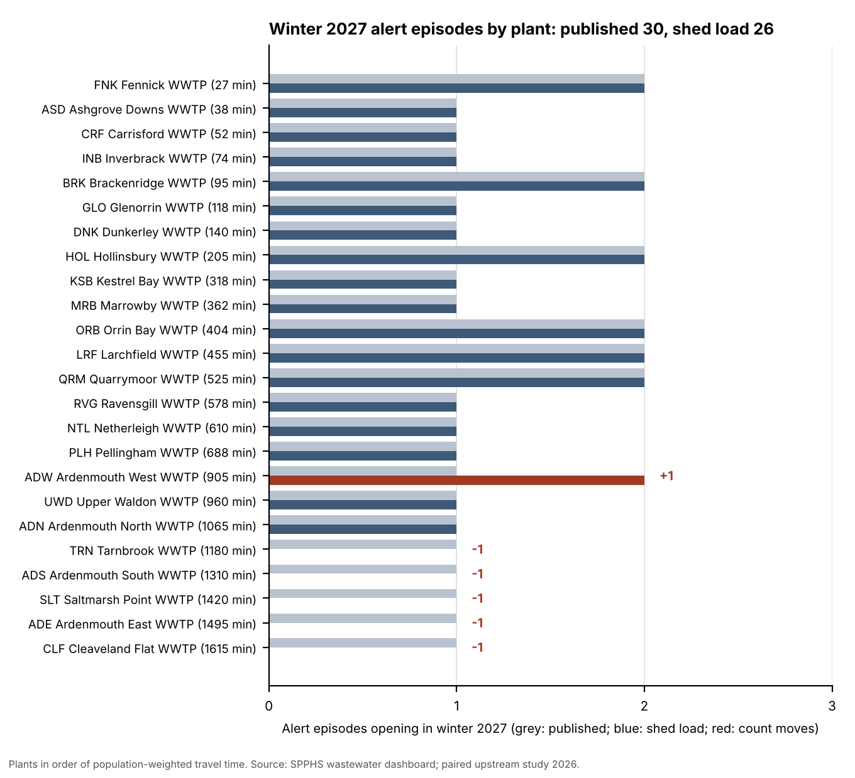
Plant | Travel time (min) | Published | Shed load | Change
ADS Ardenmouth South WWTP | 1310 | 1 | 0 | -1
ADE Ardenmouth East WWTP | 1495 | 1 | 0 | -1
ADW Ardenmouth West WWTP | 905 | 1 | 2 | +1
TRN Tarnbrook WWTP | 1180 | 1 | 0 | -1
CLF Cleaveland Flat WWTP | 1615 | 1 | 0 | -1
SLT Saltmarsh Point WWTP | 1420 | 1 | 0 | -1
All 24 plants |  | 30 | 26 | -4
The plants whose count moves; the other 18 keep theirs. Ardenmouth West's one published episode (opened the week of 31 May, closed the week of 13 September 2027) splits in two on the shed load. Source: the dashboard's export (published); the workbook, sheet Episodes (shed load).
The paired upstream study shows the sewer destroying the RNA faster in warm water: at Cleaveland Flat, at the end of a 1,615-minute trunk sewer, the study's composites lost 0.69 log10 between the trunk's head and the plant in December to February and 0.31 in June to August. Fitted over all 101 paired visits, the decay rate is 0.050 an hour at 20 degrees and rises about 9 per cent a degree. A plant's baseline is set in the summer lull, when its samples lose the most, so restoring each sample at the rate for its own water temperature lifts the baseline more than the winter samples at the long trunk sewers, and the winter rises there that came from the colder water alone fall away.
A correction that does not move over the year (one decay rate over each plant's travel time, or the samples divided by their PMMoV) lifts a plant's baseline and its winter samples alike and gives back the published 30.
From 1 May the desk also takes the historian's flow and the faecal-strength check: over the year to 31 March the historian had 1,083 hours without a valid inlet flow reading across the 24 plants, and 71 composites since October fail the check; both are by plant in the workbook.
Episodes opening in the weeks starting 3 May to 27 September 2027 (methods note v4, sections 4 and 5). Published: each sample's N1 load per person. Shed load: each sample's load with the RNA lost in the sewer restored at the paired study's decay rate for the composite's inlet temperature over the plant's population-weighted travel time; baselines recomputed (section 6.1). Plants in order of travel time.
Sources: Public Health Laboratory results export and notes; the contract laboratory's report WL-2801; Southern Plains Water inlet historian export and note; site register; travel-time memo (November 2025); paired upstream study, 2026; dashboard methods note v4.

